 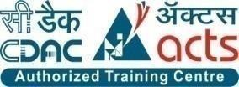

INSTITUTE FOR ADVANCED COMPUTING AND SOFTWARE DEVELOPMENT AKURDI, PUNE

Documentation On

“AmigoTech.in ”

E-Commerce Website for Techno Parts & Products

PG-DAC March 2022

**Submitted By:**

**Group No: 98**

**Roll No. Name:**

**223223 Uday Wankar**

**223176 Preetam Sarkar**

**Mr. Prashant Karhale Mr. Manjri Deshpande**

**Centre Coordinator Project Guide**

# ABSTRACT

This project is a web-based shopping system for an existing shop. The project objective is to deliver the online shopping application into web platform.

This project is an attempt to provide the advantages of online shopping to customers of a real shop. It helps buying the products in the shop anywhere through internet by using a website device. Thus, the customer will get the service of online shopping and home delivery from his favorite shop. This system can be implemented to any shop in the locality or to multinational branded shops having retail outlet chains.

If shops are providing an online portal where their customers can enjoy easy shopping from anywhere, the shops won’t be losing any more customers to the trending online shops such as Flipkart or e-bay. Since this application is available in the Smartphone it is easily accessible and always available.

# ACKNOWLEDGEMENT

I extend my sincere and heartfelt thanks to our esteemed guide, **Mr. Mrs.Manjri Deshpande** for providing me with the right guidance and advice at the crucial juncture sand for showing me the right way. I extend my sincere thanks to our respected **Centre Co-Ordinator Mr. Prashant Karhale**, for allowing us to use the facilities available. I would like to thank the other faculty members also, at this occasion.

**Uday Wankar (223223)**

**Preetam Sarkar (223176)**

**Table of Contents**

ABSTRACT 2

ACKNOWLEDGEMENT 3

INTRODUCTION 7

FEATURES 8

1.1PROJECT OBJECTIVE 10

1.2PROJECT OVERVIEW 11

1.3PROJECT SCOPE 12

1.4STUDY OF THE SYSTEM 13

1.4.1Use Cases 13

1.4.1.1Administrator 13

1.4.1.2Customer 17

3.1 System Tools 21

3.1.1 FRONT END 21

3.1.2BACKEND 21

DATABASE DESIGN 22

3.2DATABASE 27

A LEVEL 0 DFD 23

B LEVEL 1 DFD 24

E-R Diagram 25

TABLE STRUCTURE 26

PROJECT DIAGRAMS 31

CONCLUSION 59

REFERENCES 60

LIST OF FIGURES

FIGURE 1: ADMIN ACTIVITY DIAGRAM 11

FIGURE 1: ADMIN ACTIVITY DIAGRAM --------------------------------------------------------13

FIGURE 2: CUSTOMER ACTIVITY DIAGRAM-------------------------------------------------16

FIGURE 3: Level 0 DFD --------------------------------------------------------------------------------22

FIGURE 4: Level 1 DFD----------------------------------------------------------------------------------23

FIGURE 5:E-R Diagram----------------------------------------------------------------------------------24

FIGURE 6:UI Diagram-----------------------------------------------------------------------------------30

**INTRODUCTION**

This project is a web-based shopping system for an existing shop. An Online Shopping Management System where the Admin can Add, Update and Delete products. The Products are divided into various categories of electronic products. A user can select a particular item to view the details, choose the number of items and fill in details like Name, Address, etc. to buy a product the project objective is to deliver the online shopping application into web platform. Online shopping is the process whereby consumers directly buy goods or services from a seller in real- time, without an intermediary service, over the Internet. It is a form of electronic commerce. This project is attempts provide the advantages of online shopping to customers of a real shop. It helps buying the products in the shop anywhere through internet by using an android device. Thus, the customer will get the service of online shopping and home delivery from his favorite shop.

The objective of the project is to make an application in android platform to purchase items in an existing shop. In order to build such an application complete web support, need to be provided. A complete and efficient web application which can provide the online shopping experience is the basic objective of the project.

**Features:** -

The basic functionality that must be fulfilled by the app are listed below , the web application is Single page Website to display ,filter, sort, buy and manage the products in the shop list.

**1. Shopping Portal**-

Web site (Web Application) (Online Store) Create the one stop shop for the electronics gadgets/appliances so ease buying, selling sorting and management on product.

**2. Uniform Access:**

Consumers, suppliers, sellers, staff, BOD, admin would be able manage same web site.To grant a uniform access to all the customer and the admin (user) to access the website concurrently enabling them to buy, sell or manage products. It should not conflict the user accessibility for concurrent access.

**3. Product Gallery & Product Details (Product Catalog)**

Showcase all the products and there details in a easy and proficient manner so that the user will be able to view and get the desired one. It should avoid any repeatability or ambiguity in the data if any. All the basic details should be available and the additional info if needed can be viewed in particular product details.

**4. Login, Logout and OTP authentication for password reset.**

Secured Login, Logout feature is provided for user accessibility. Additional to this OTP authentication via Email is to be supported for password reset in case the password is forgot by the user or if any technical issue adheres.

**5. Order Processing, Bill generation.**

All the product that user chooses to buy must me packaged in a single cart while ordering and the order is to be generated with unique ID at the time of order processing. The order is to be converted in bill for the payment purpose with the invoice generation of the order done with payment.

**6. Payment processing** (support for all types of payment mode integration)

Consumers can pay via different payment gateway such as Bill Junction, Bill Desk. Consumer will be provided with all EMI Plans via OSS according to cart/Product value. Cash on Delivery option will be available for Customers.

**7. Shipping parcels at customer end as well Tracking Delivery**

Once the payment has been done it’s the responsibility of owner to dispatch the item to the customer in the stipulated time with assurity of product quality and in the desired time span. In future this can be automated via delivery partners to ease the business flow and get the optimum service.

**8. Customer Relationship management**

The platform should value the customer and always welcome any feedbacks, complains from the user. To facilitate this there are the option to contact admin, write a feedback or comment and this comments showed to all to user and admin to ensure the transparency in the quality.

**9. Seller Dashboard**

A single dashboard to display all sales, track the growth of business for analysis and planning of product management is to be provided that will ease to list out the consumption of the product and will also help to list out non selling item if any.

**10. Staff/Admin will monitor product Catalog**

Order cancellation, order keeping on hold feature should be available to cancel any order after the payment is done. Based on customer feedback or because of any reason if some product found having flaw then the selling of that particular item should be ceased on priority to avoid customer problem.

**Future Scope:**

**11. Allow promotions for top sale, low price Dhamaka promotion, clearance, festival promotions**

For the business growth and for customer happiness the additional offers are levied on special occasions like festivals or any special day which will attract more customer and will boost up the sale.

* 1. **PROJECT OBJECTIVE**

AmigoTech OSS is Web application. It is intended to provide online solution for technical gadgets and appliances to consumers as one stop solution platform using internet. OSS will enable sellers to set up online store. Customers will be able to purchase products through virtual store. OSS would perform online business process automation such as one Shopping Cart management, Order Processing, Payment Processing, Customer Relationship Management as well as Shipment of ordered products.

The aim is to made all technical gadgets which are rare / unknown on a single platform to ease development activity for development and ease of mankind living.

* 1. **PROJECT OVERVIEW**

Any anonymous user will be able to view different products available for sale. Products will be displayed based on brand, category, cost, rating, views, etc.

Users will be able to get details of the product chose from list presented. For each user OSS will maintain Shopping Cart. User will be able add product item.

With expected quantity. It would be added to shopping cart maintained for the user. User can update or remove product items from Shopping Cart.

OSS will allow registered customers to place an order. Registered customers would be able to check order history. Registered customer would be able to provide.

Feedback against order, product as well as service received from admin. Registered Customer would be able to change his/her personal information whenever he required. Registered Customer would be able track delivery against the order been placed. Registered customer would be able to cancel his order within 24 hours.

Registered customers would be redirected for payment processing with the help of Payment Gateway interfacing. On success full payment result from payment gateway, Shopping Cart items would be converted into order and receipt generated. Approved order will be dispatched for Delivery.

Admin would be able to access OSS based on role assigned, would be able to monitor online products, orders, payments through their dashboard. Admin would be able to get information about orders being placed, rejected, on hold. Admin would be able to change status of order been placed if required. Admin would be able change their personal information through their dashboard. We can get Quarterly products Sales information via OSS. The web app will support additional discounts or offers to be levied on any product proposed by supplier.

* 1. **PROJECT SCOPE**

The Scope of our project is to make web application for Technical gadgets and appliances. The application will provide user friendly interface for searching, buying, listing, delivering (for logistics) electronic gadgets/appliances (UI Design). Also to make application to be secured (e.g. only registered Customers can see their order history & also for suppliers).

OSS allows Admin to maintain their products in product Catalog based on their availability. The application to be secured (only registered Customers can see their order history)

* 1. **STUDY OF THE SYSTEM**

## Use Cases:

The system after careful analysis has been identified to be presented with the following modules and roles.

The modules involved are:

* + - * Guest/User
      * Admin/Staff.
      1. **Administrator:**

The administrator is the super user of this application. Only admin have access into this admin page. Admin may be the owner of the shop. The administrator has all the information about the users and about all products.

This module is divided into different sub modules.

* + - * 1. Manage Staff.
        2. Manage Products
        3. Manage Users
        4. Manage Orders
        5. Manage Product delivery.

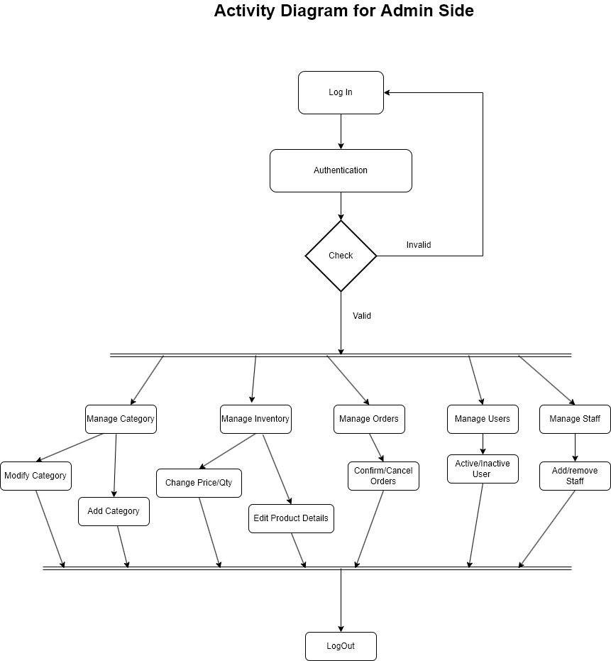

*Figure 1 Admin Activity Diagram*

* **Add Products**

The shopping cart contains different kinds of products of different category. The products can be classified into different categories by name. Admin can add new products into the existing system with all its details including an image.

* **Delete Products**

Administrator can delete the products based on the stock of that particular product.

* **Search Products**

Admin will have a list view of all the existing products. He can also search for a particular product by name.

* **Update Product**
* Admin can update existing products into the existing system with all its details including an image.
* **Add Staff.**

Admin have the privilege to add the Staff.

* **Remove Staff.**

Admin have the privilege to remove the Staff.

* **Search Product**

users can search the product to for their convenience.

* **Delivered Orders**

Supplier can see order details of the ordered product by the customer.

* **Pending Orders**

Supplier can see order details of the ordered product by the customer.

* P**ayments**

Supplier can see payment details of the ordered product by the customer.

* **Update profile**

Admin can update his profile.

**1.4.1.12 Customer Activity Diagram**

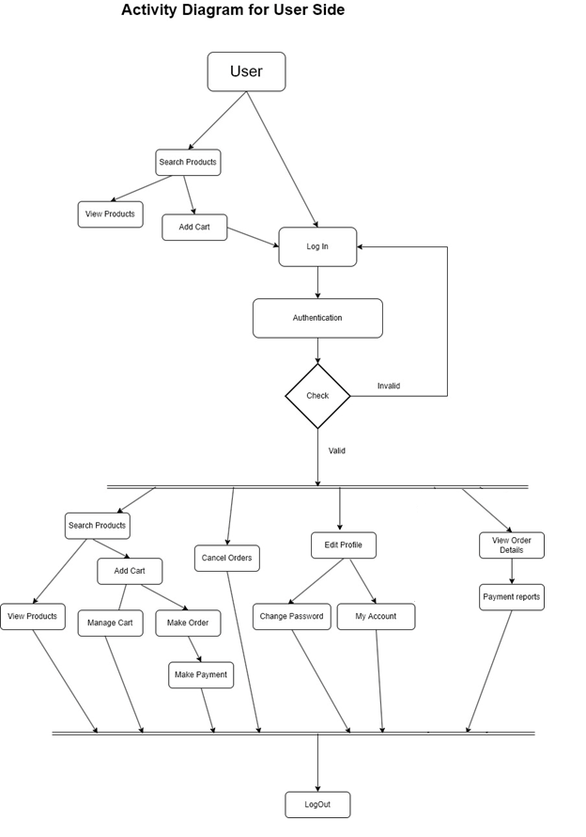

*Figure 2 Customer/User Activity Diagram*

* + **Customer sign in, sign out, create account**

This feature is provided to customer so he can sign in, sign out and create account for new customer.

* + **Search Product**

Customer can search the product as per his wish in specific category.

* + **Sort Product based on price**

Customer can sort the products based on price ascending or descending.

* + **Sort Product based on popularity**

Customer can sort the products based on popularity.

* + **Add to Cart**

Customer can add products to cart which he wants to buy the products.

* + **Payments**

Customer have a privilege to his order he can see his order details.

* + **Order Details**

Customer have a privilege to his order he can see his order details.

* + **Buy Product**

Customers can buy product from his cart by doing payment.

* + **Wish List**

Customer can have a wish list for future buying products he can add products in the wish to list.

* + **Update Profile**

Customer can update his profile details as he wants.

* + **Change Shipping address**

Customer can change /update shipping address as needed

* **Pending Orders**

Order delivery status can be viewed to manage the delivery of the products.

* 1. **SYSTEM TOOLS**

The various system tools that have been used in developing both the front end and the back end of the project are being discussed in this chapter.

* + 1. **FRONT END:**

React is a library which is developed by Facebook are utilized to implement the frontend. React (also known as React.js or ReactJS) is a [free and open-source](https://en.wikipedia.org/wiki/Free_and_open-source_software) [front-end](https://en.wikipedia.org/wiki/Front_end_and_back_end) [JavaScript](https://en.wikipedia.org/wiki/JavaScript_library) [library](https://en.wikipedia.org/wiki/JavaScript_library) for building [user interfaces](https://en.wikipedia.org/wiki/User_interfaces) or UI components. It is maintained by [Facebook](https://en.wikipedia.org/wiki/Facebook%2C_Inc) and a community of individual developers and companies. React can be used as a base in the development of [single](https://en.wikipedia.org/wiki/Single-page_application) [page](https://en.wikipedia.org/wiki/Single-page_application) or mobile applications. However, React is only concerned with state management and rendering that state to the [DOM,](https://en.wikipedia.org/wiki/Document_Object_Model) so creating React applications usually requires the use of additional libraries for routing, as well as certain client-side functionality.

Node.js: uses non-blocking, event-driven I/O to remain lightweight and efficient in the face of data-intensive real-time applications that run across distributed devices.

* + 1. **BACKEND:**

The back end is implemented using MySQL which is used to design databases.

**MySQL:**

MySQL is the world's second most widely used open-source relational database management system (RDBMS). The SQL phrase stands for Structured Query Language. An application software called Navicert was used to design the tables in MySQL.

**Spring-Boot:**

The main goal of the **Spring Boot** framework is to reduce overall development time and increase efficiency. **It reduces lots of development time and increases productivity**. It avoids writing lots of boilerplate Code, Annotations and XML Configuration. It is very easy to integrate Spring Boot Application with its Spring Ecosystem like Spring JDBC, Spring ORM, Spring Data, Spring Security etc

This is used to connect MYSQL and fetch data from database and store the data in database. The Spring Framework is a[n application framework](https://en.wikipedia.org/wiki/Application_framework) and [inversion of control](https://en.wikipedia.org/wiki/Inversion_of_control) [container](https://en.wikipedia.org/wiki/Servlet_container) for the [Java](https://en.wikipedia.org/wiki/Java_platform) [platform.](https://en.wikipedia.org/wiki/Java_platform) The framework's core features can be used by any Java application, but there are extensions for building web applications on top of the [Java EE](https://en.wikipedia.org/wiki/Java_EE) (Enterprise Edition) platform. Although the framework does not impose any specific [programming model,](https://en.wikipedia.org/wiki/Programming_model) it has become popular in the Java community as an addition to the [Enterprise JavaBeans](https://en.wikipedia.org/wiki/Enterprise_JavaBeans) (EJB) model. The Spring Framework is Open-source Framework.

# DATABASE DESIGN

* 1. **DATABASE**

Databases are the storehouses of data used in the software systems. The data is stored in tables inside the database. Several tables are created for the manipulation of the data for the system. Two essential settings for a database are

* Primary key - the field that is unique for all the record occurrences
* Foreign key - the field used to set relation between tables Normalization is a technique to avoid redundancy in the tables.

1. **Data Flow Diagram**
2. **Level 0 Diagram**

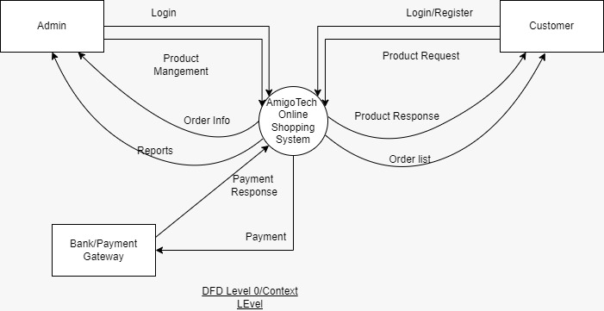

***Figure 3 Level 0 DFD***

1. **Level 1 Diagram**

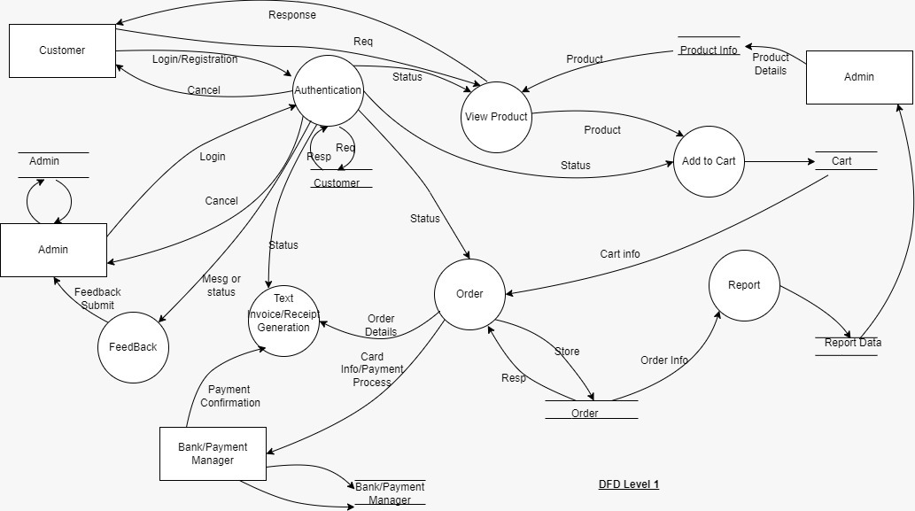

***Figure 4 Level 1 DFD***

# E-R Diagram:

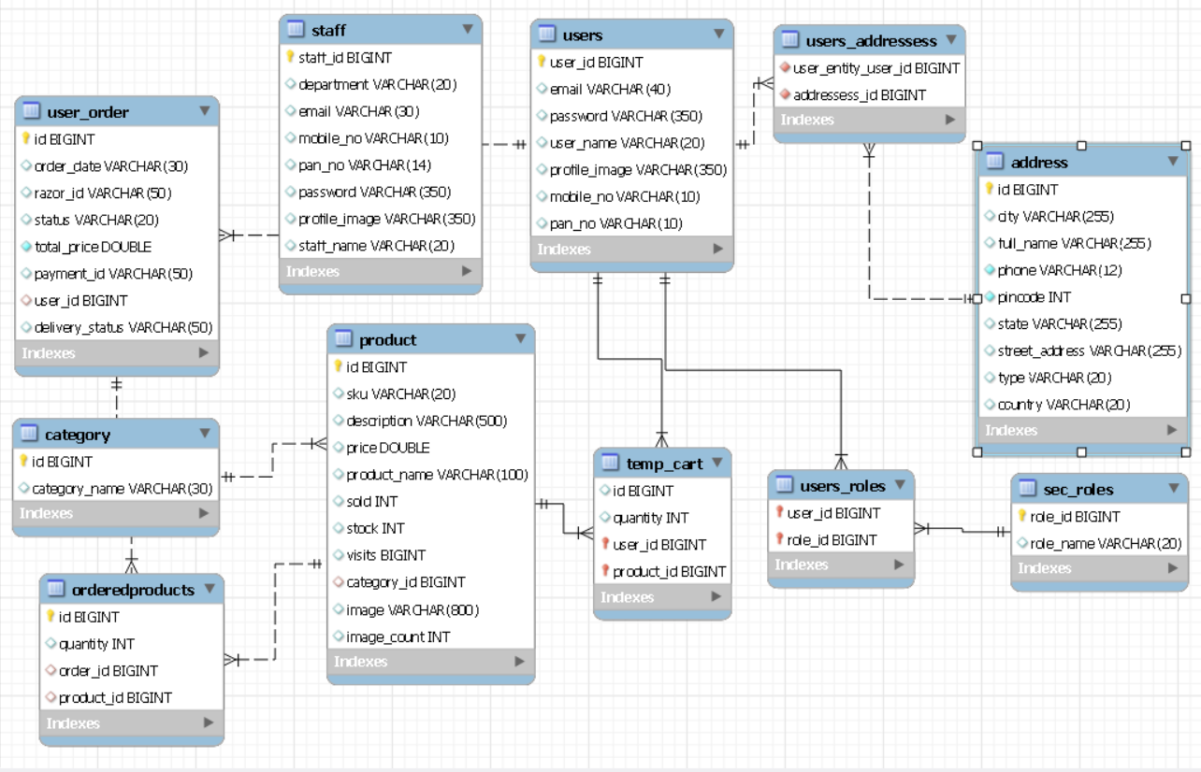

***Figure 5 E-R Diagram***

# TABLE STRUCTURE:

**Tables:**

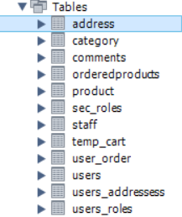

**Address:**

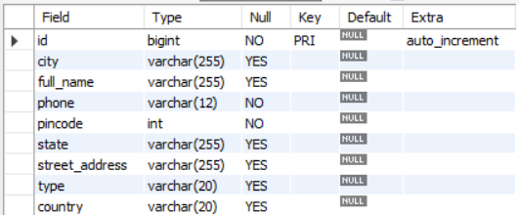

**Category:**

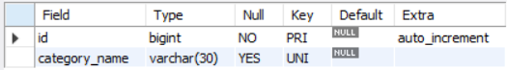

**Comments:**

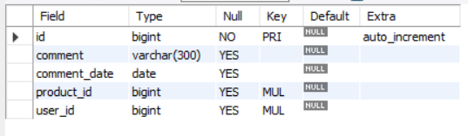

**Orderedproducts:**

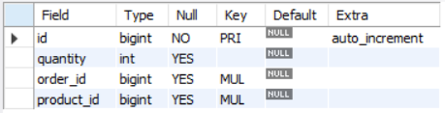

U**sers_roles;**

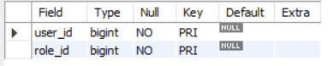

**Products:**

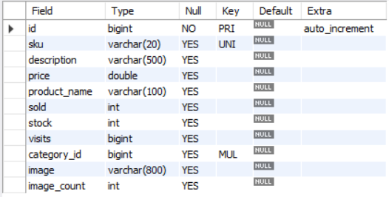

**Sec_roles:**

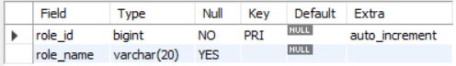

**Staff:**

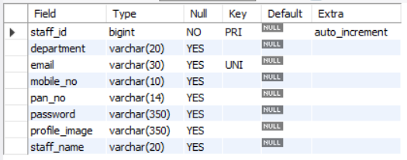

**Temp_cart:**

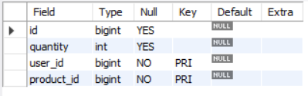

**user_order:**

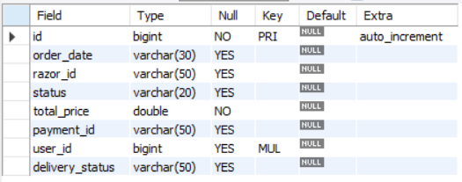

**User :**

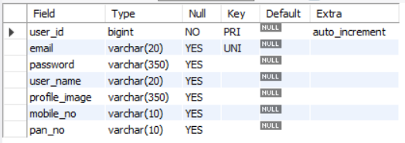

**users_addressess:**

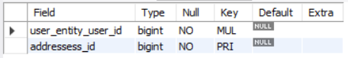

**UI Diagram.**

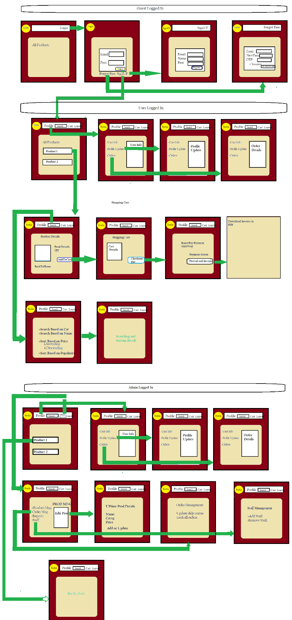

# PROJECT Snaps

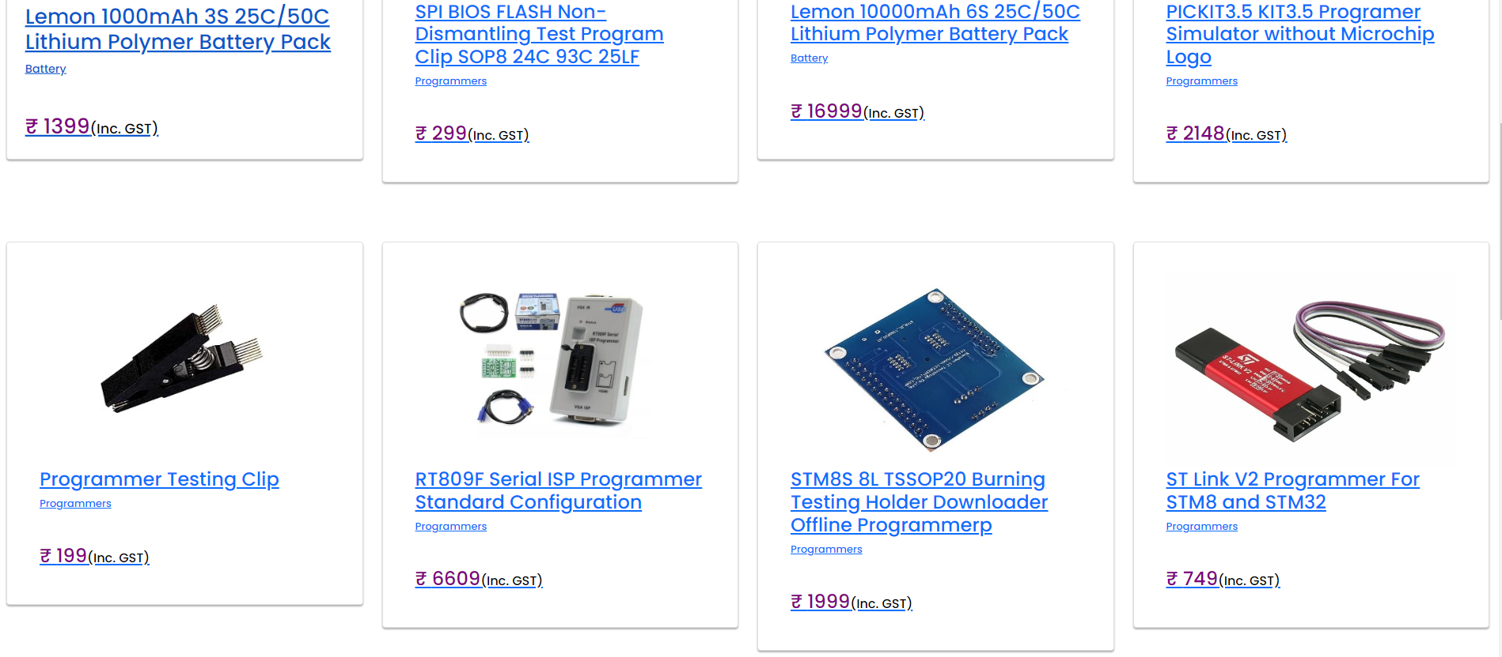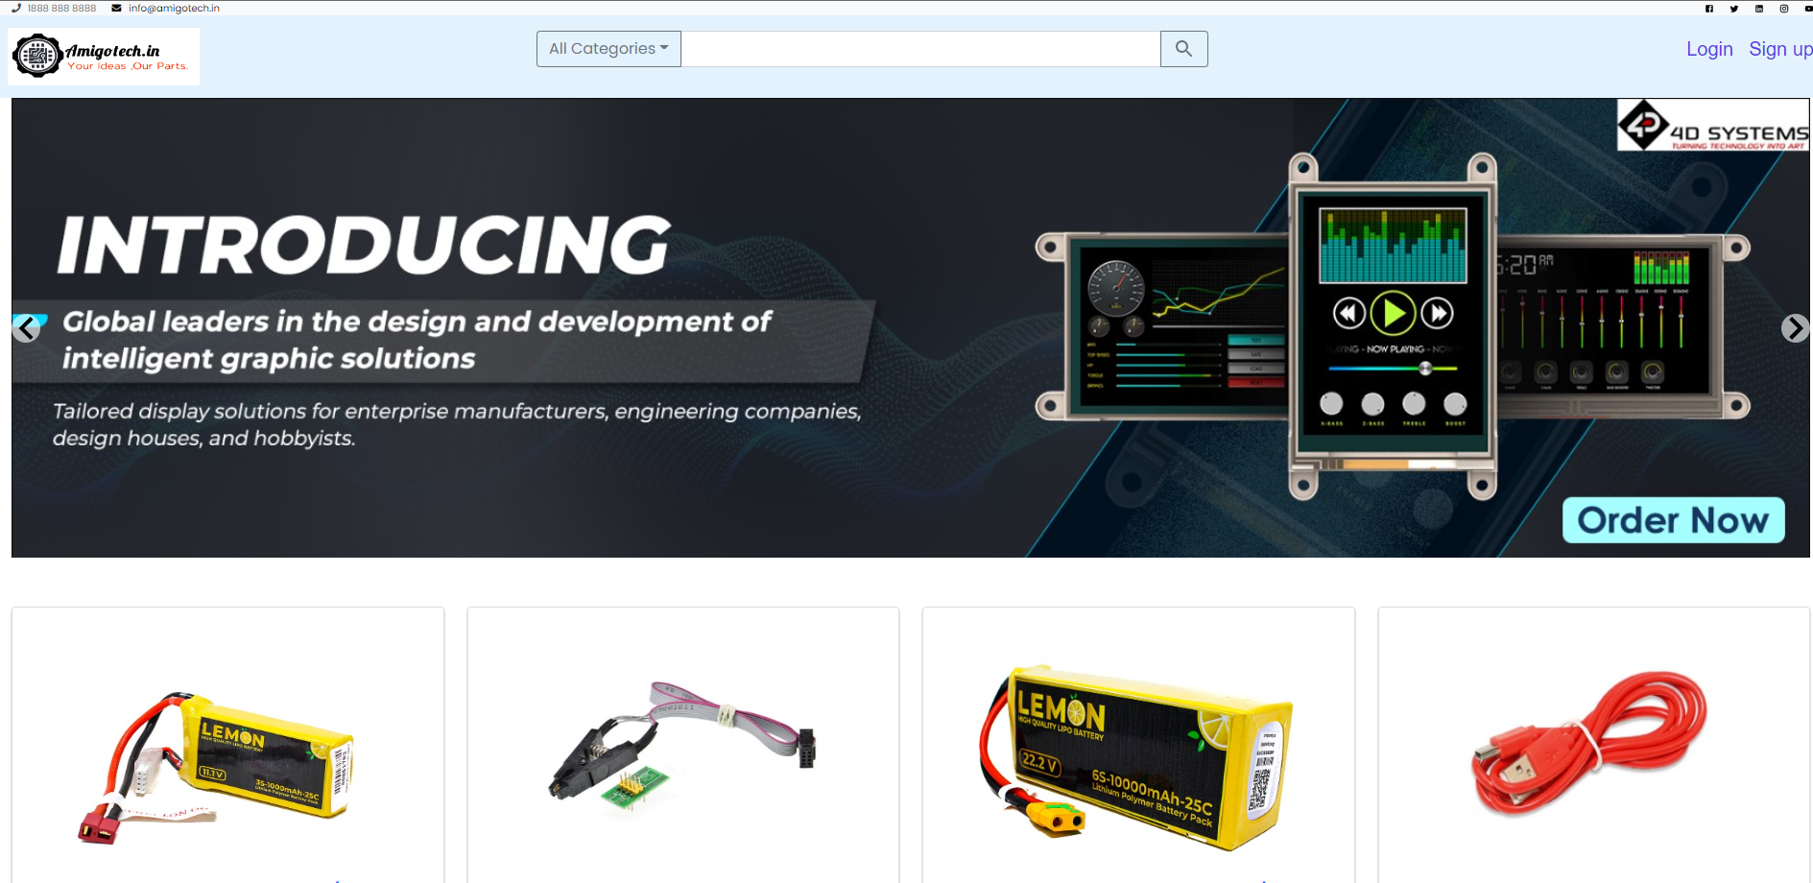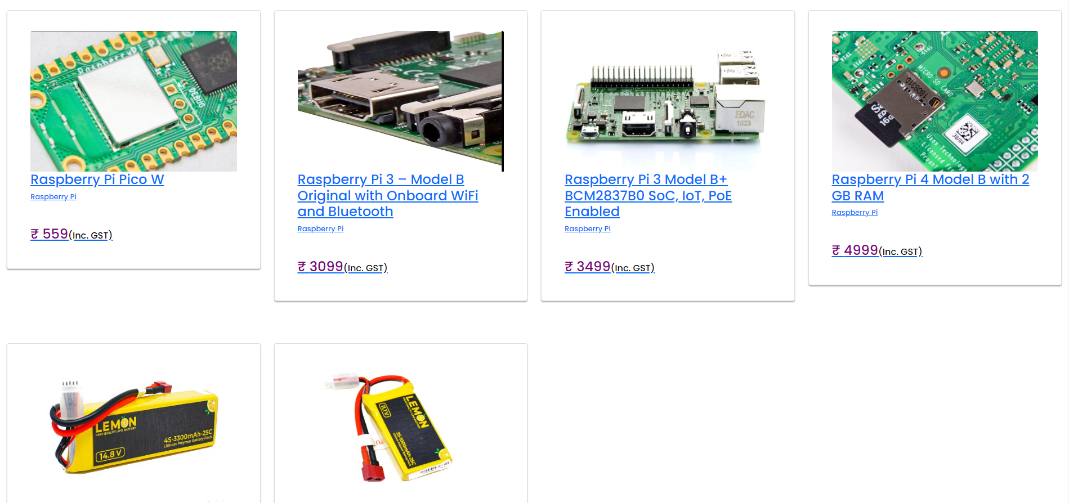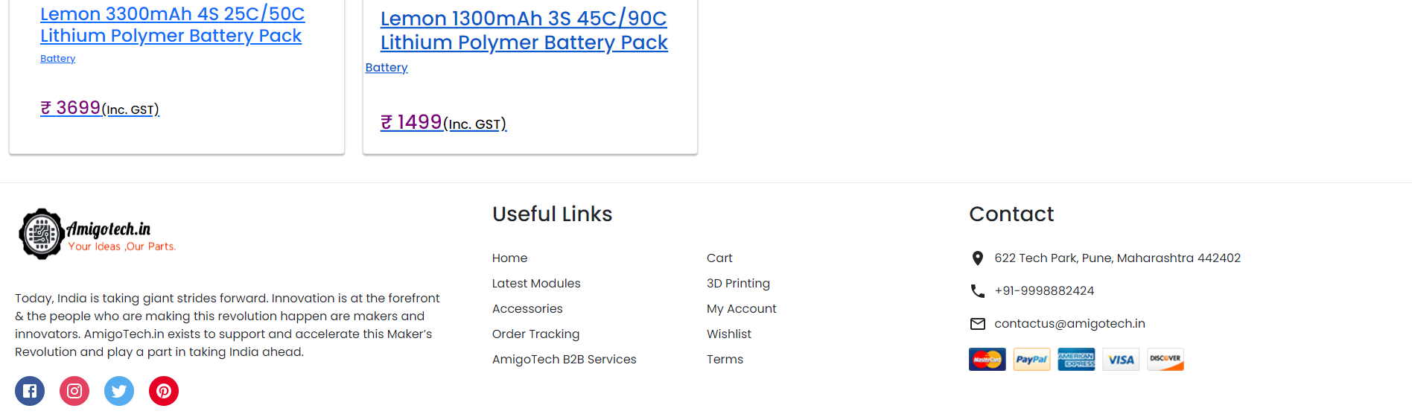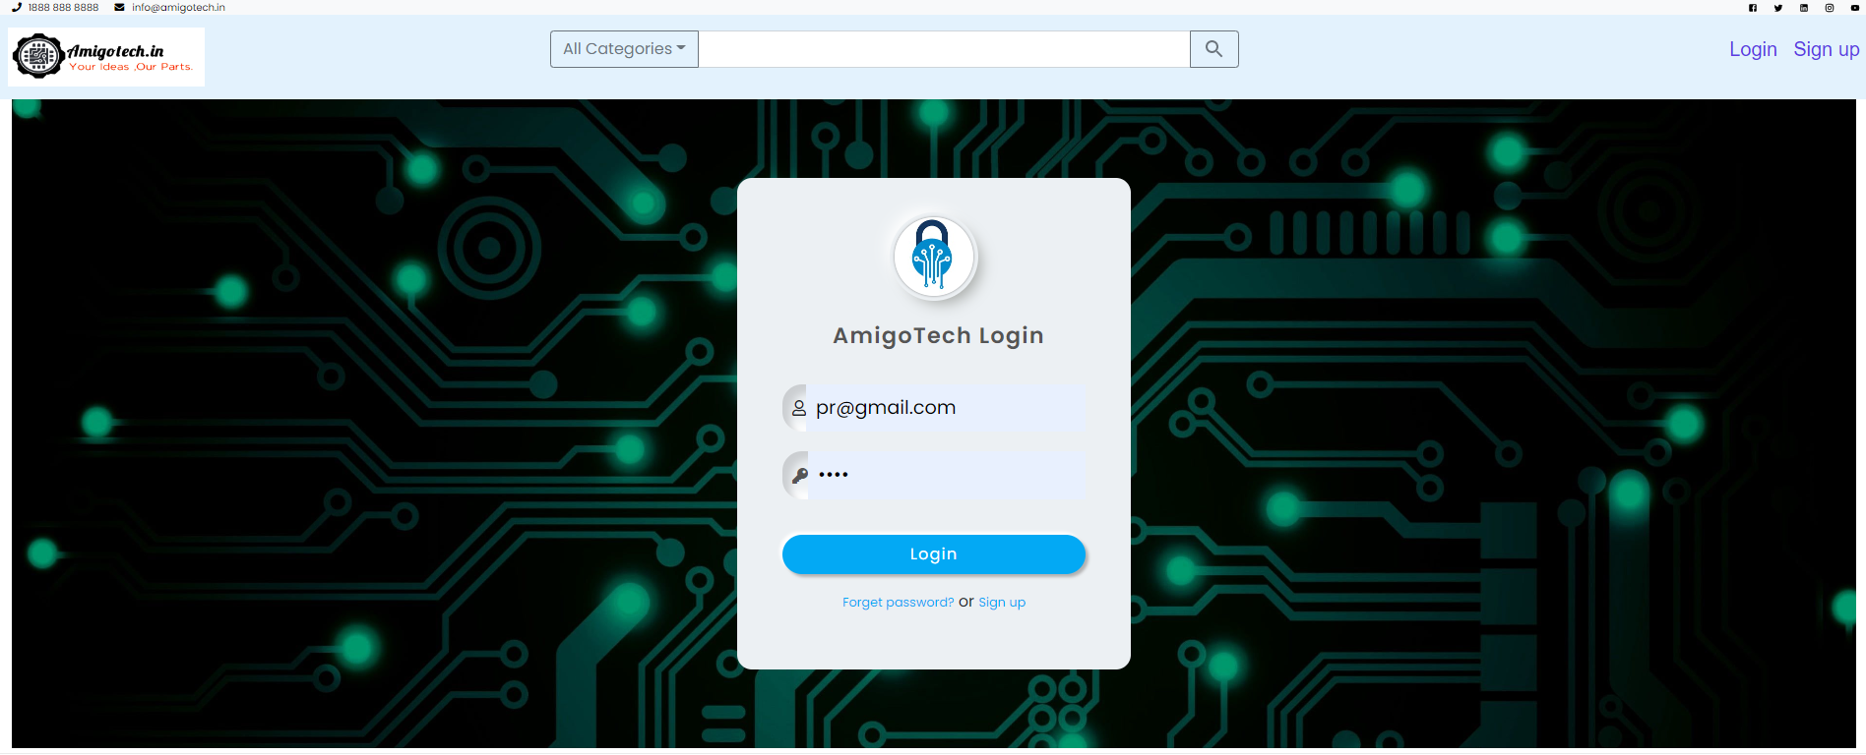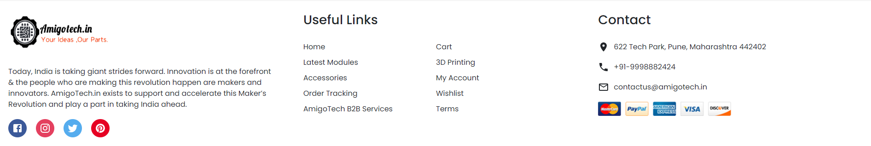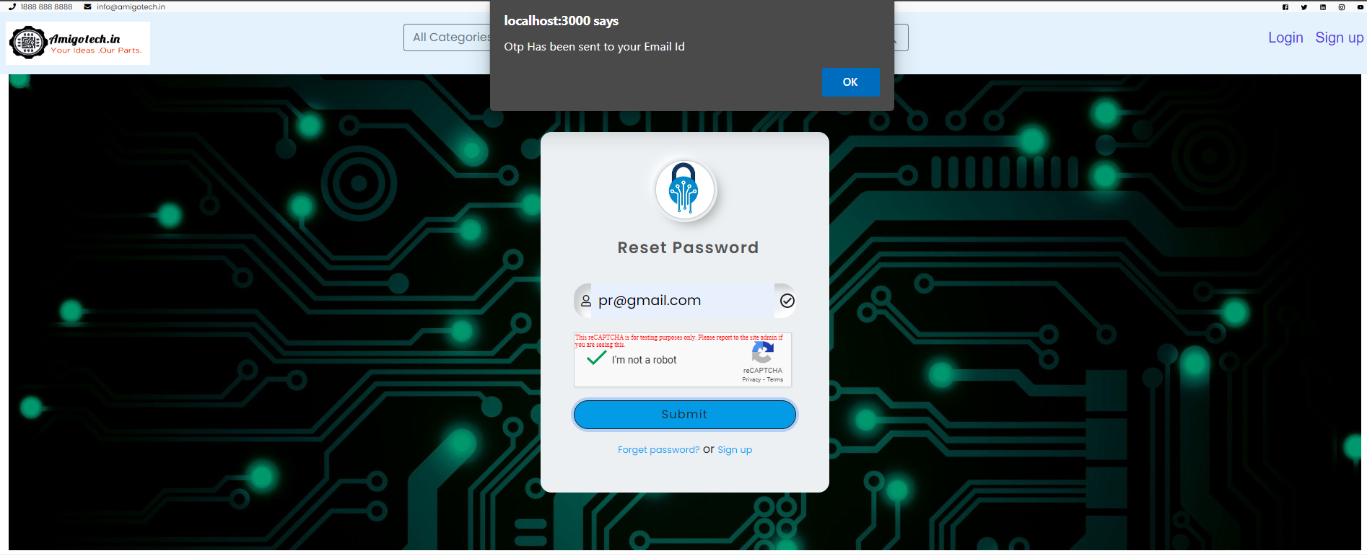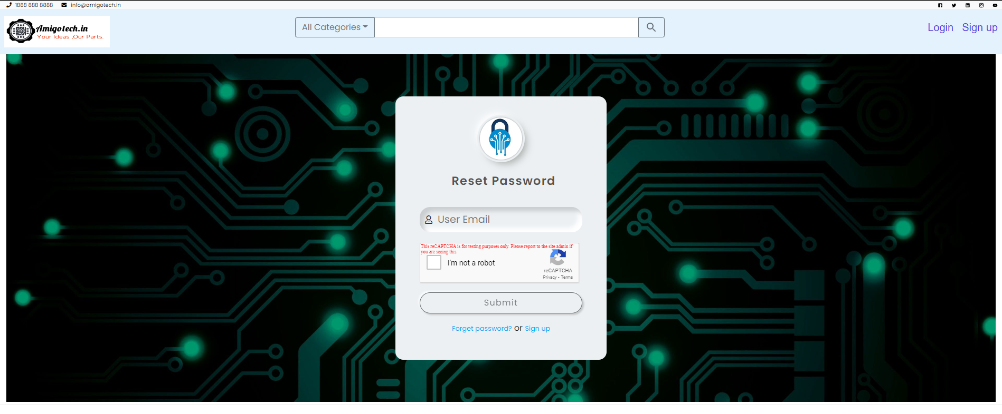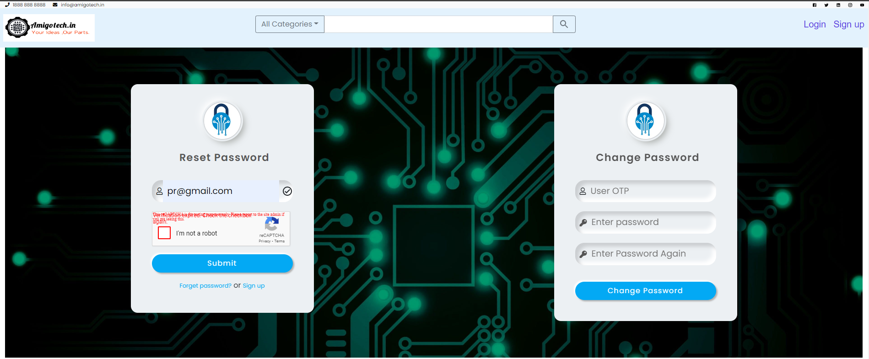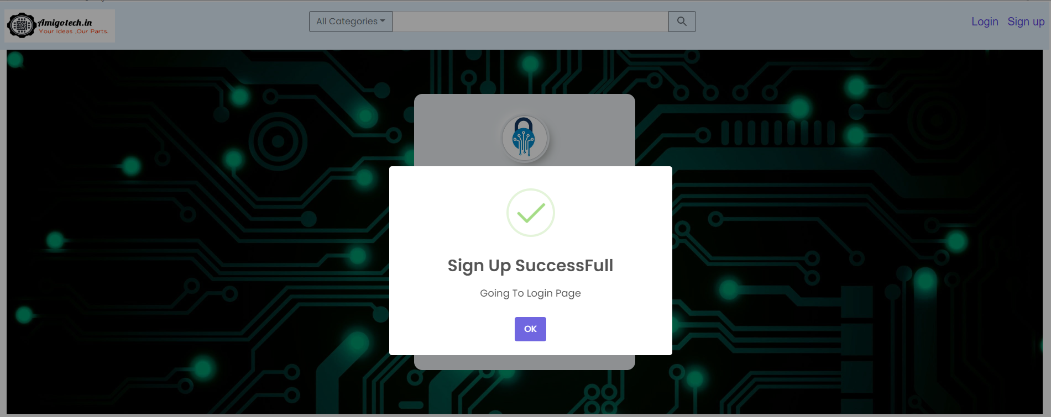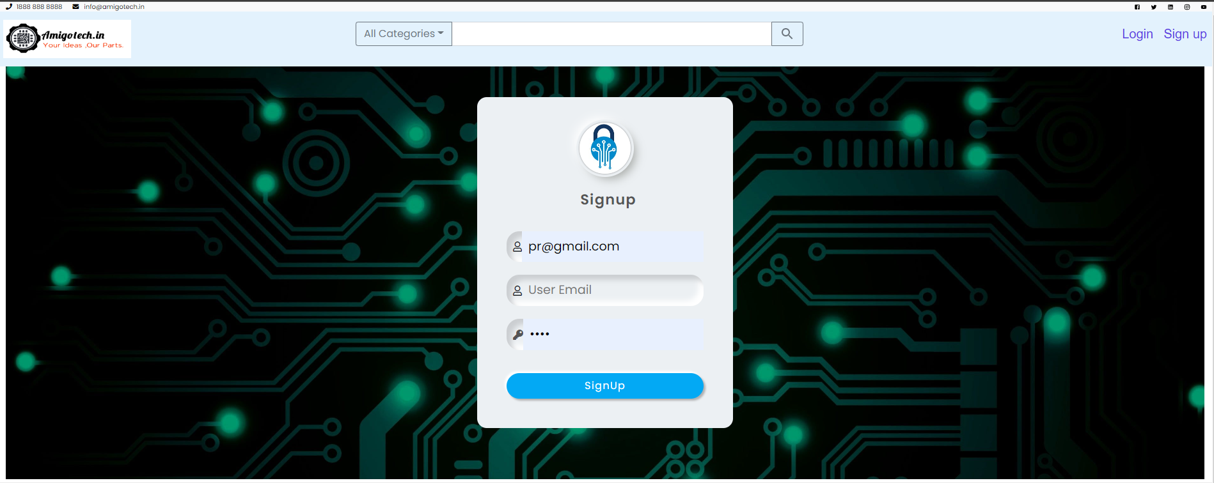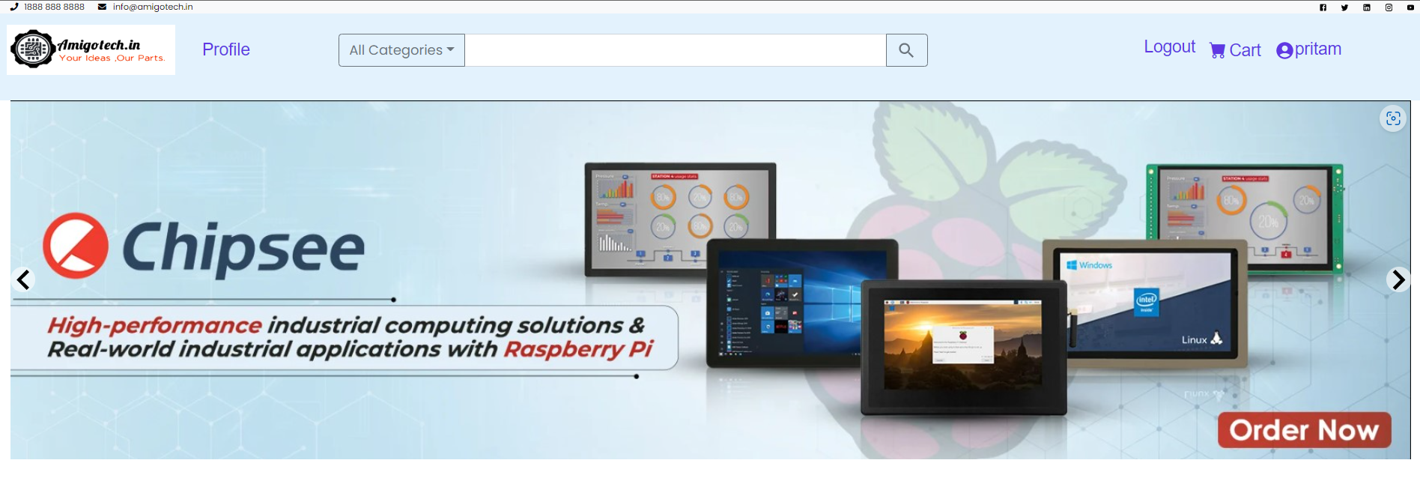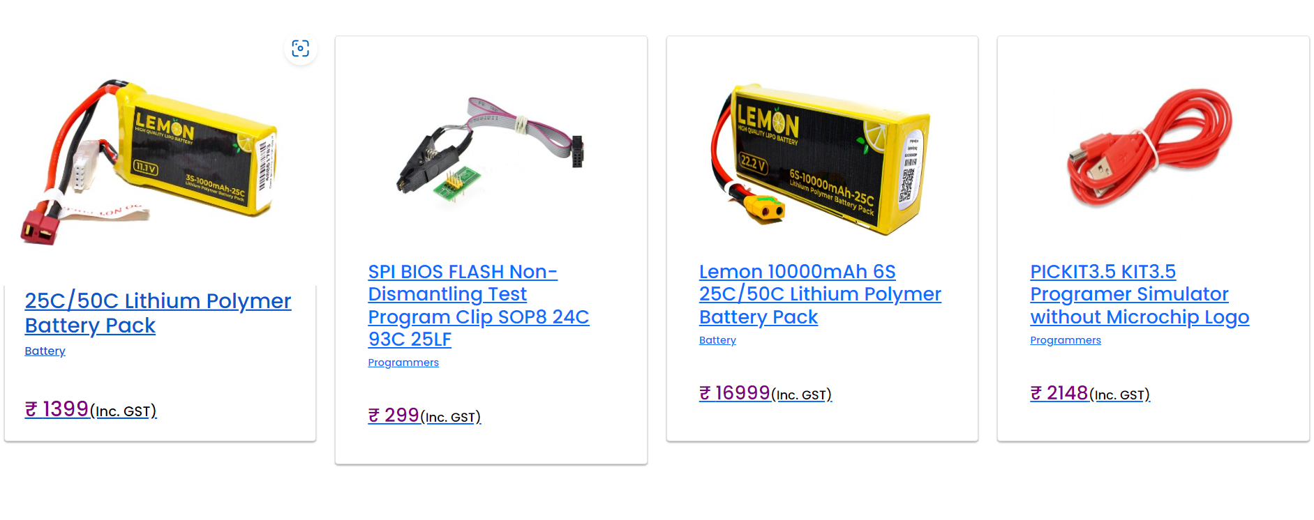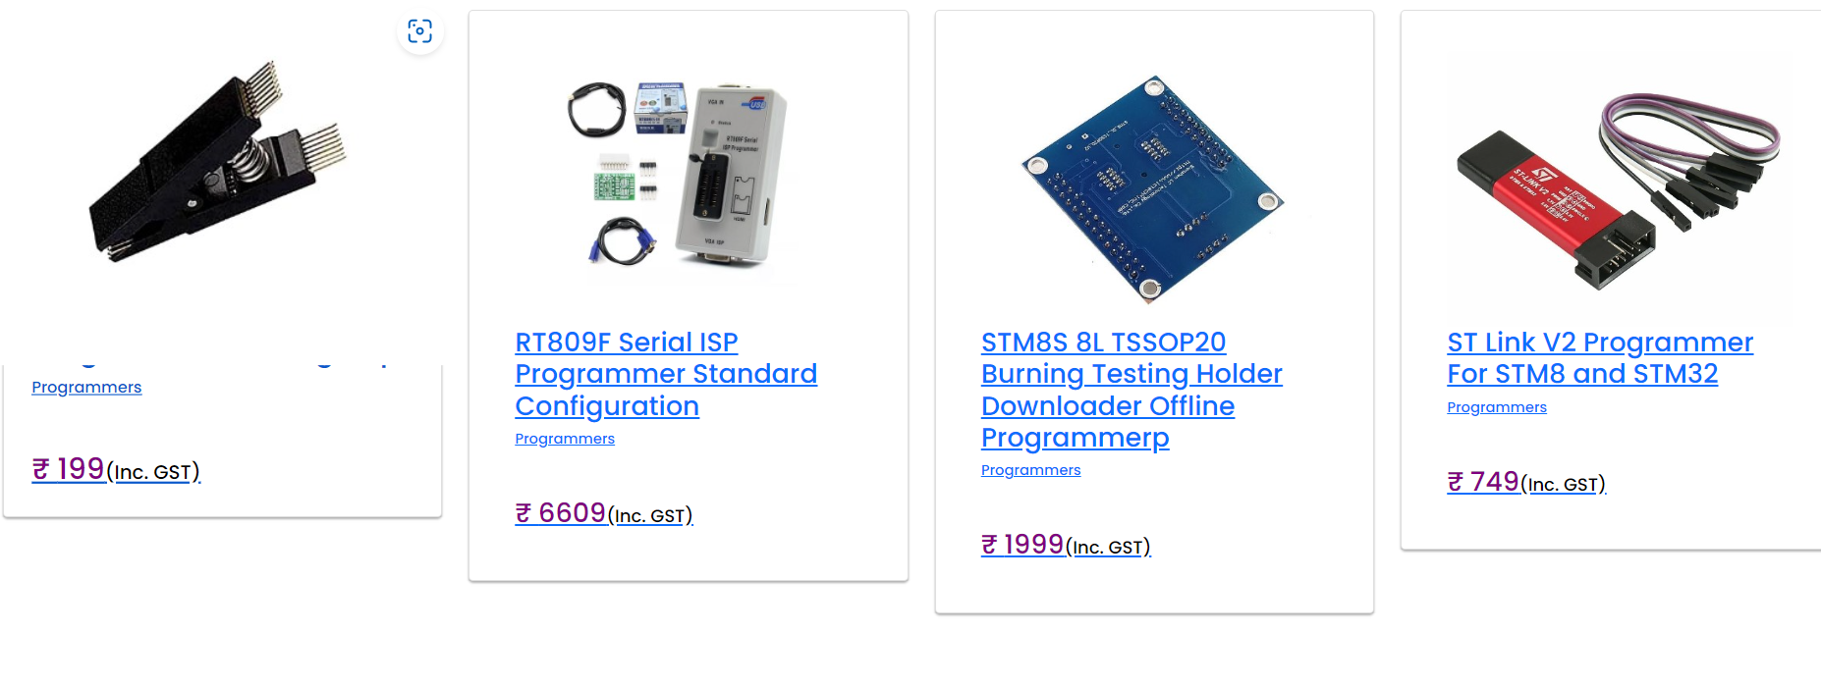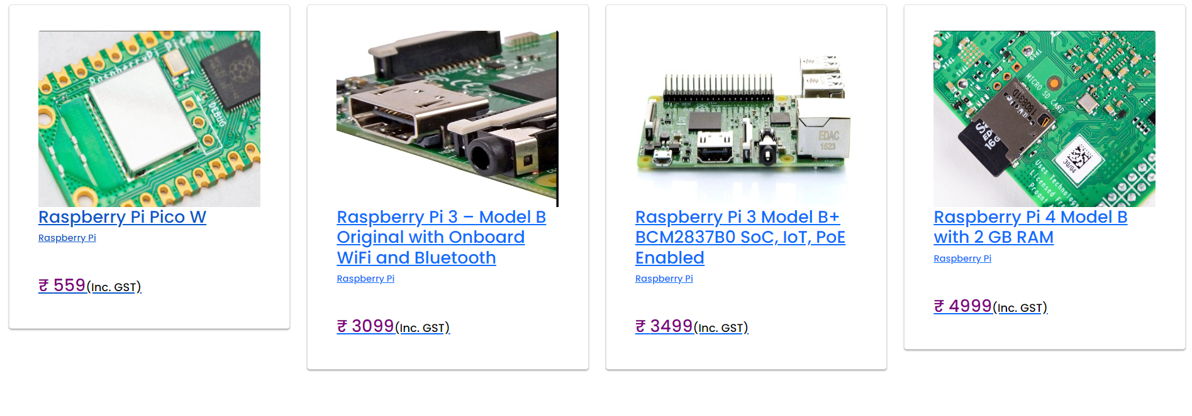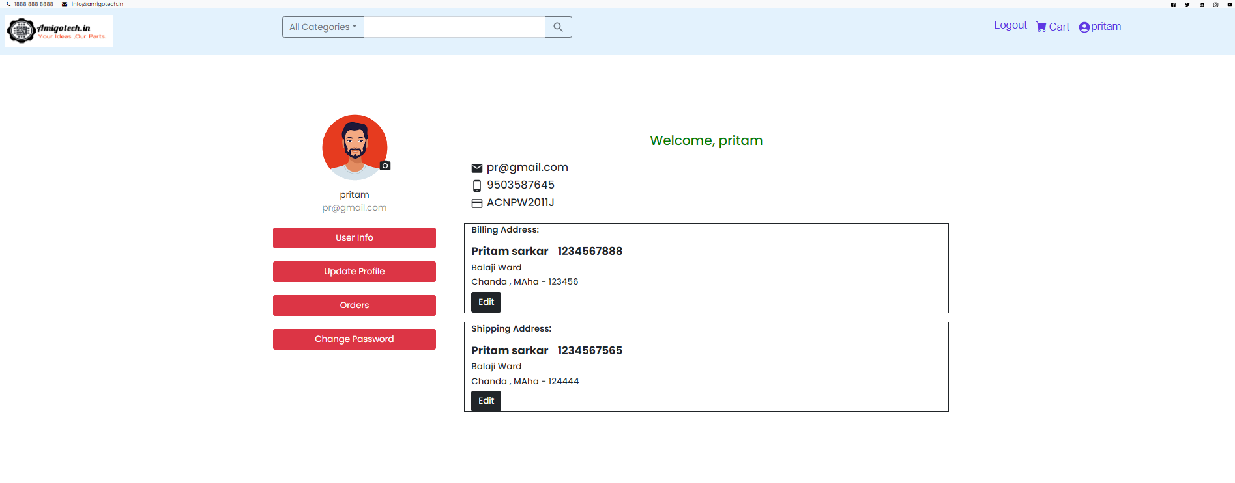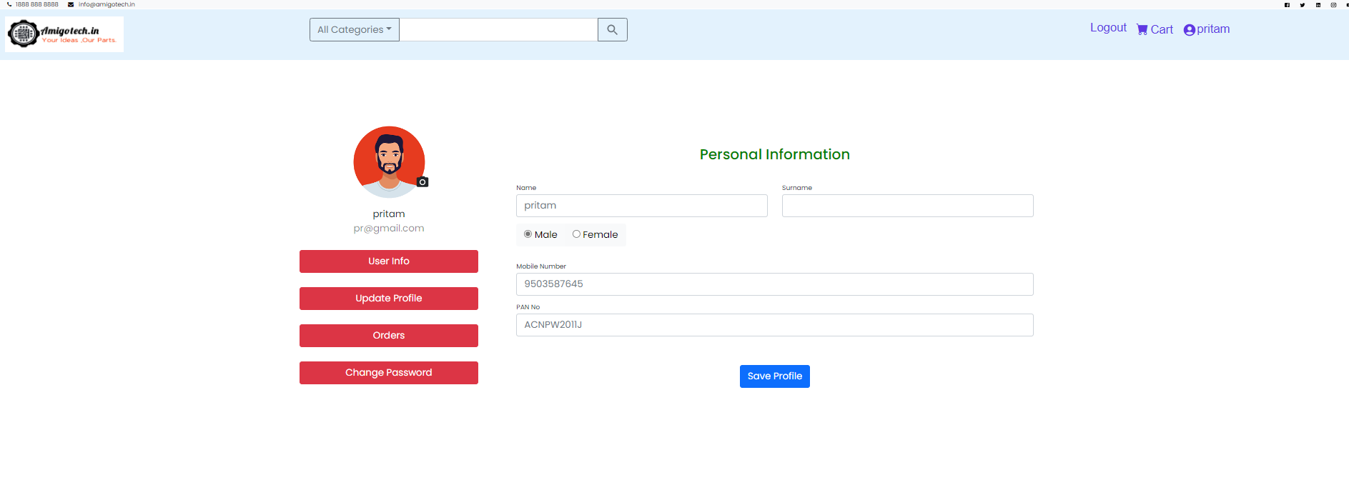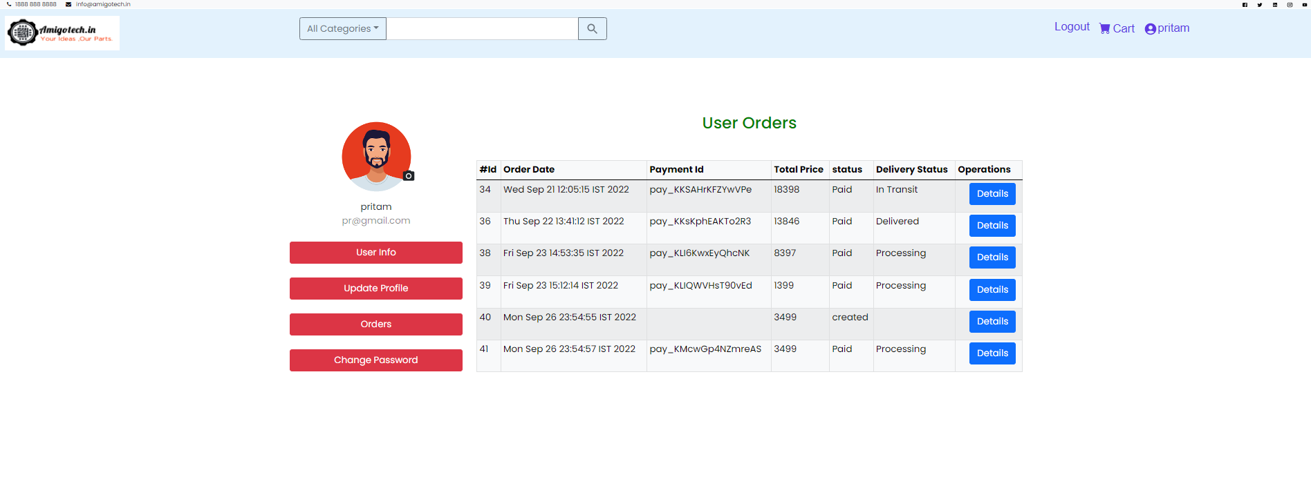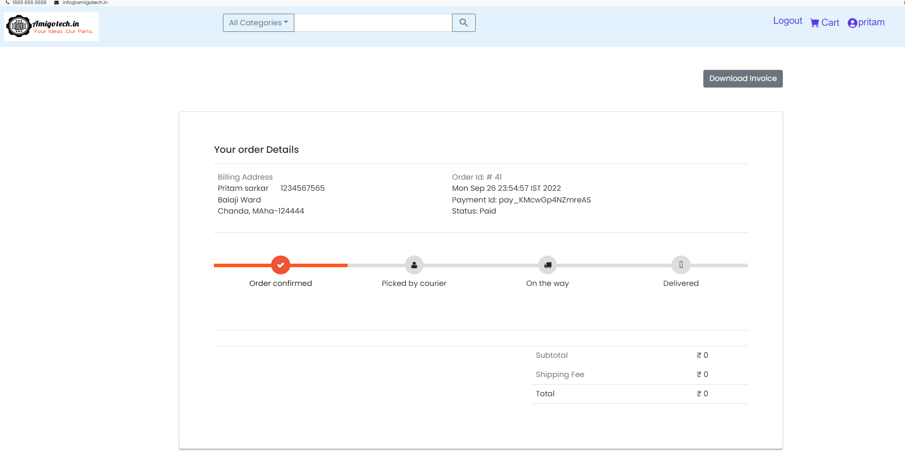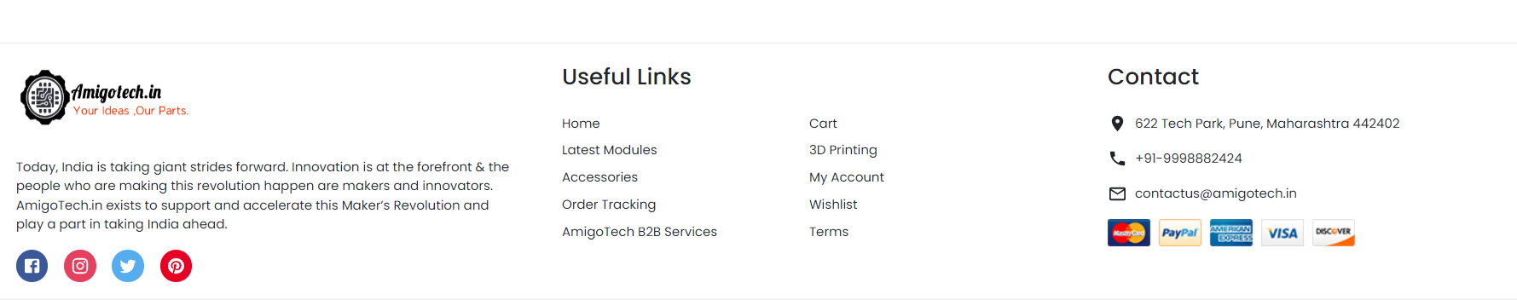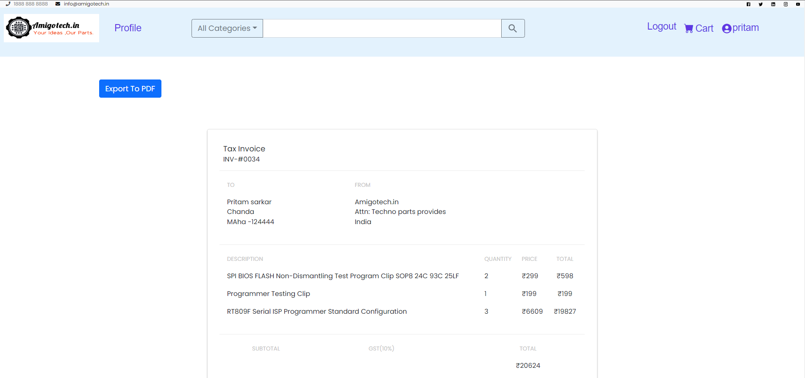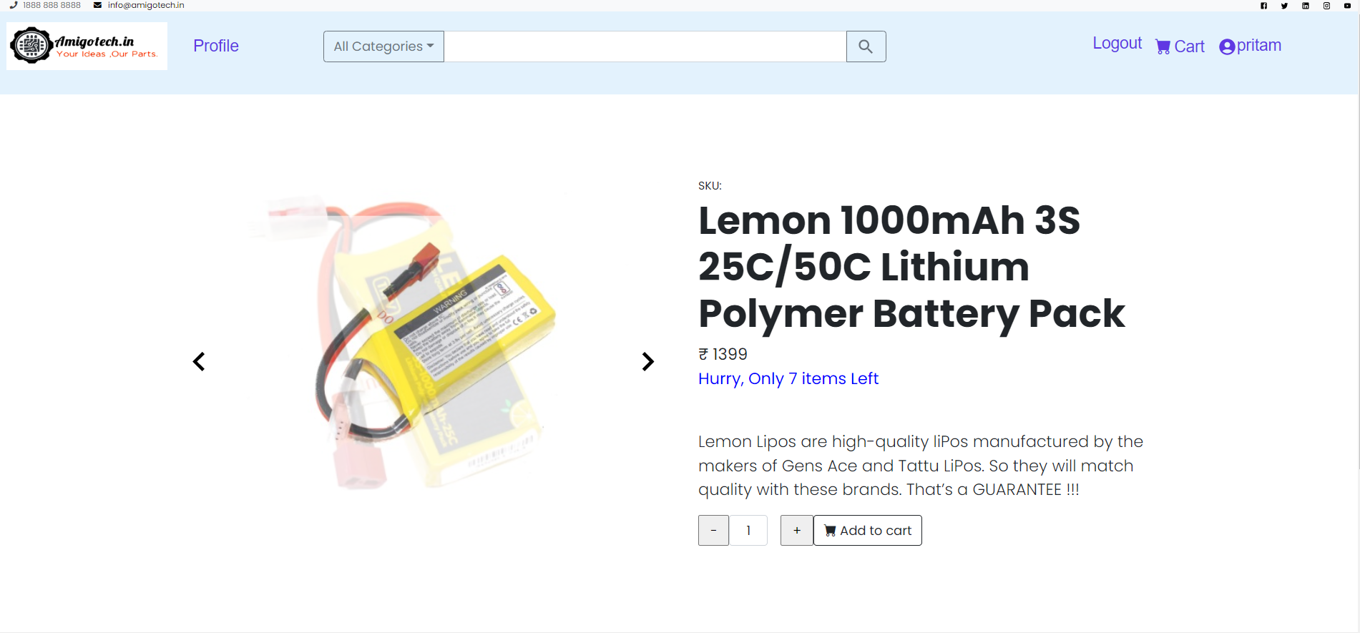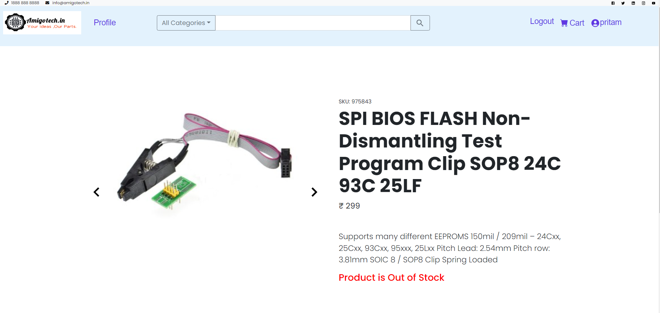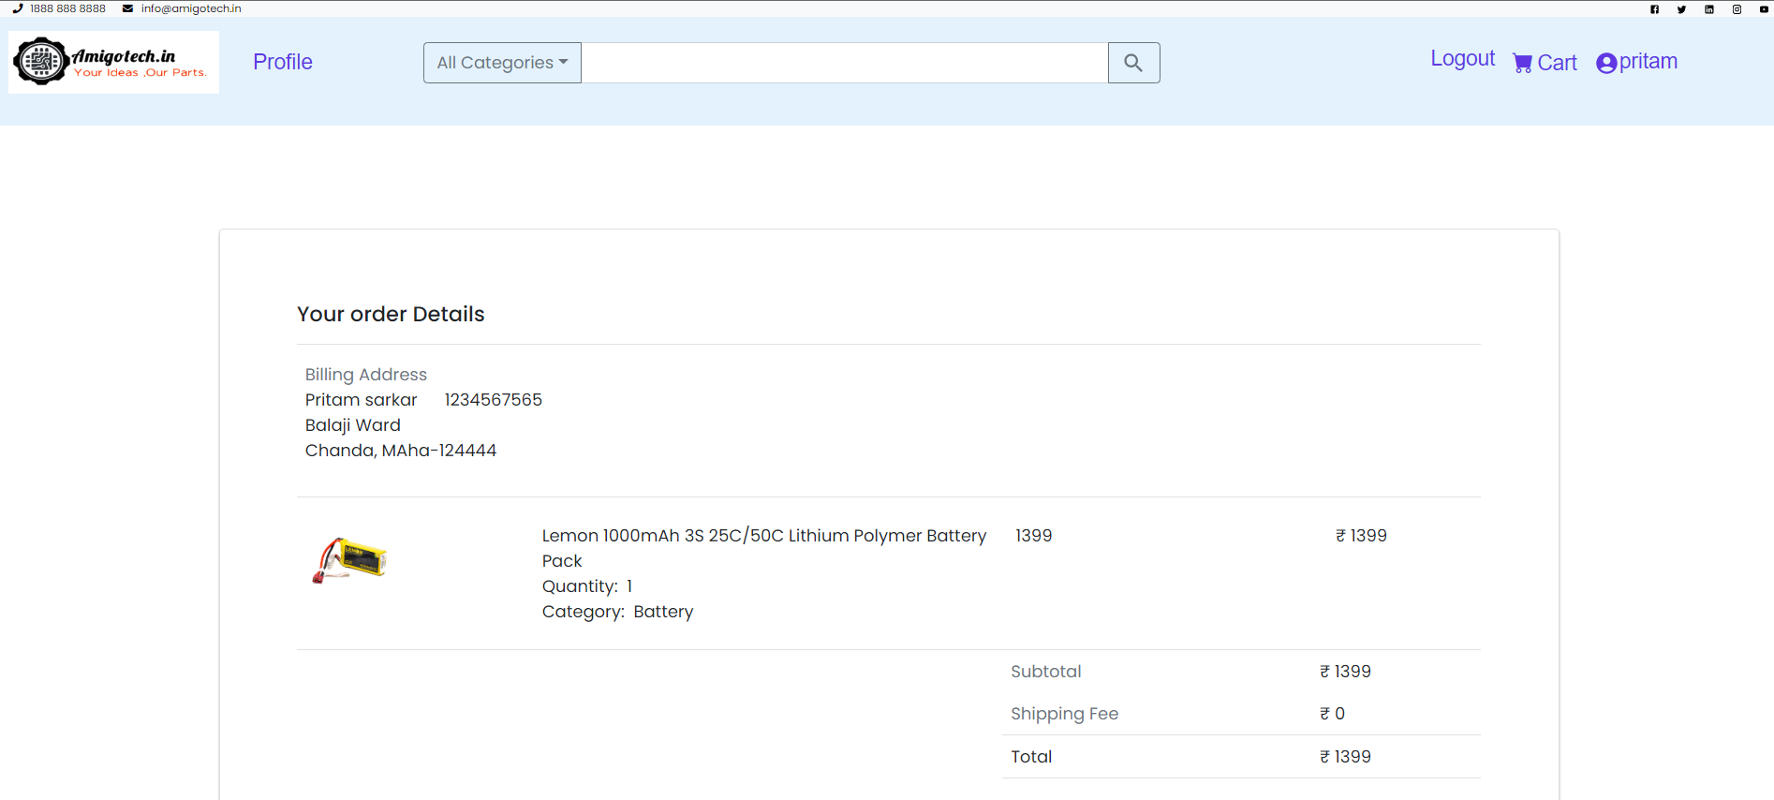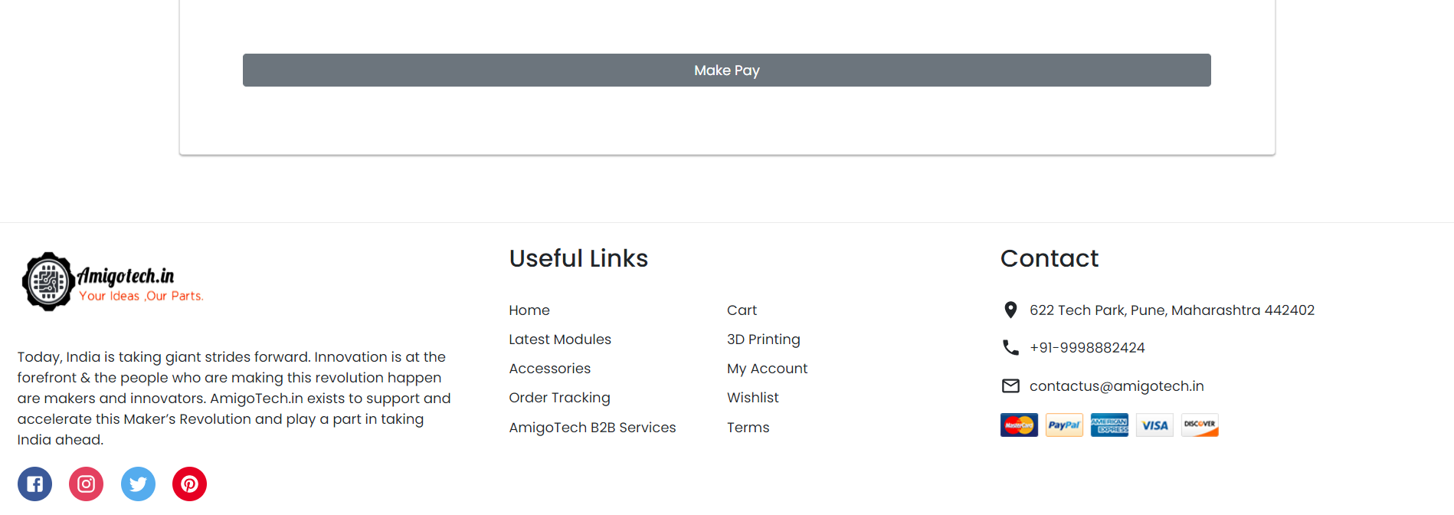

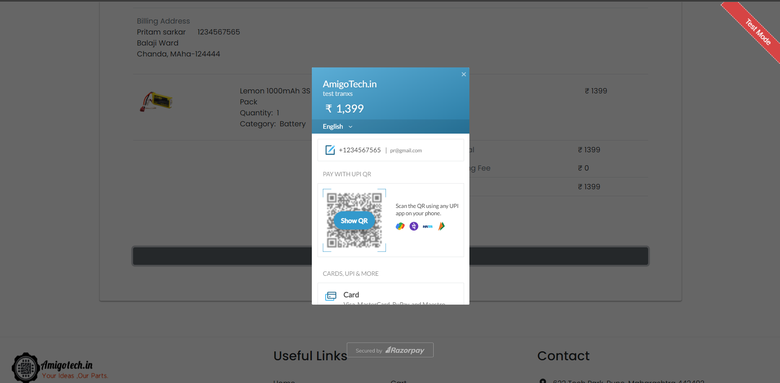

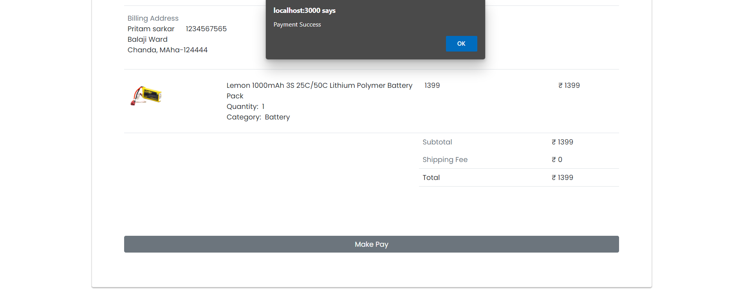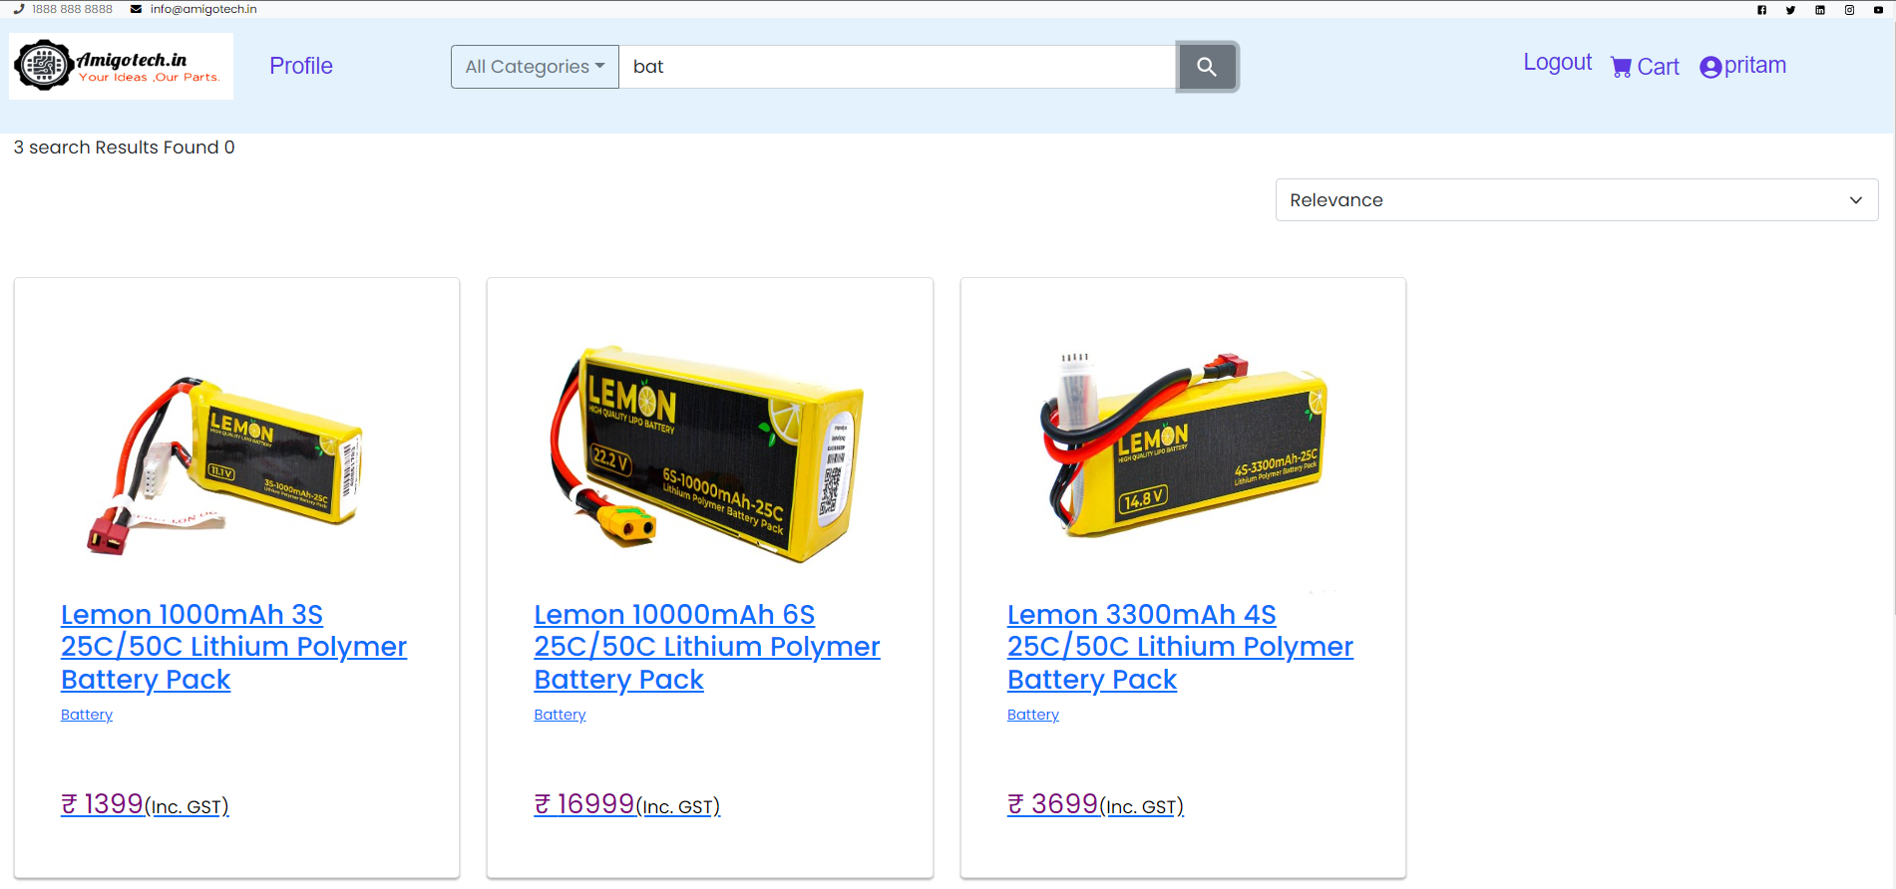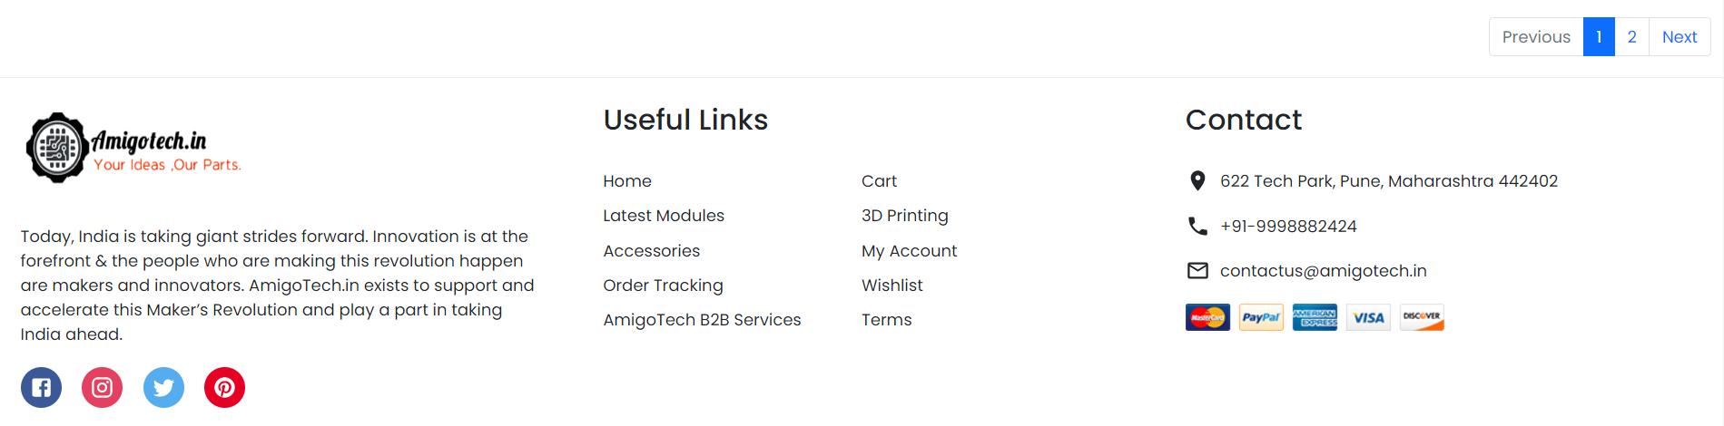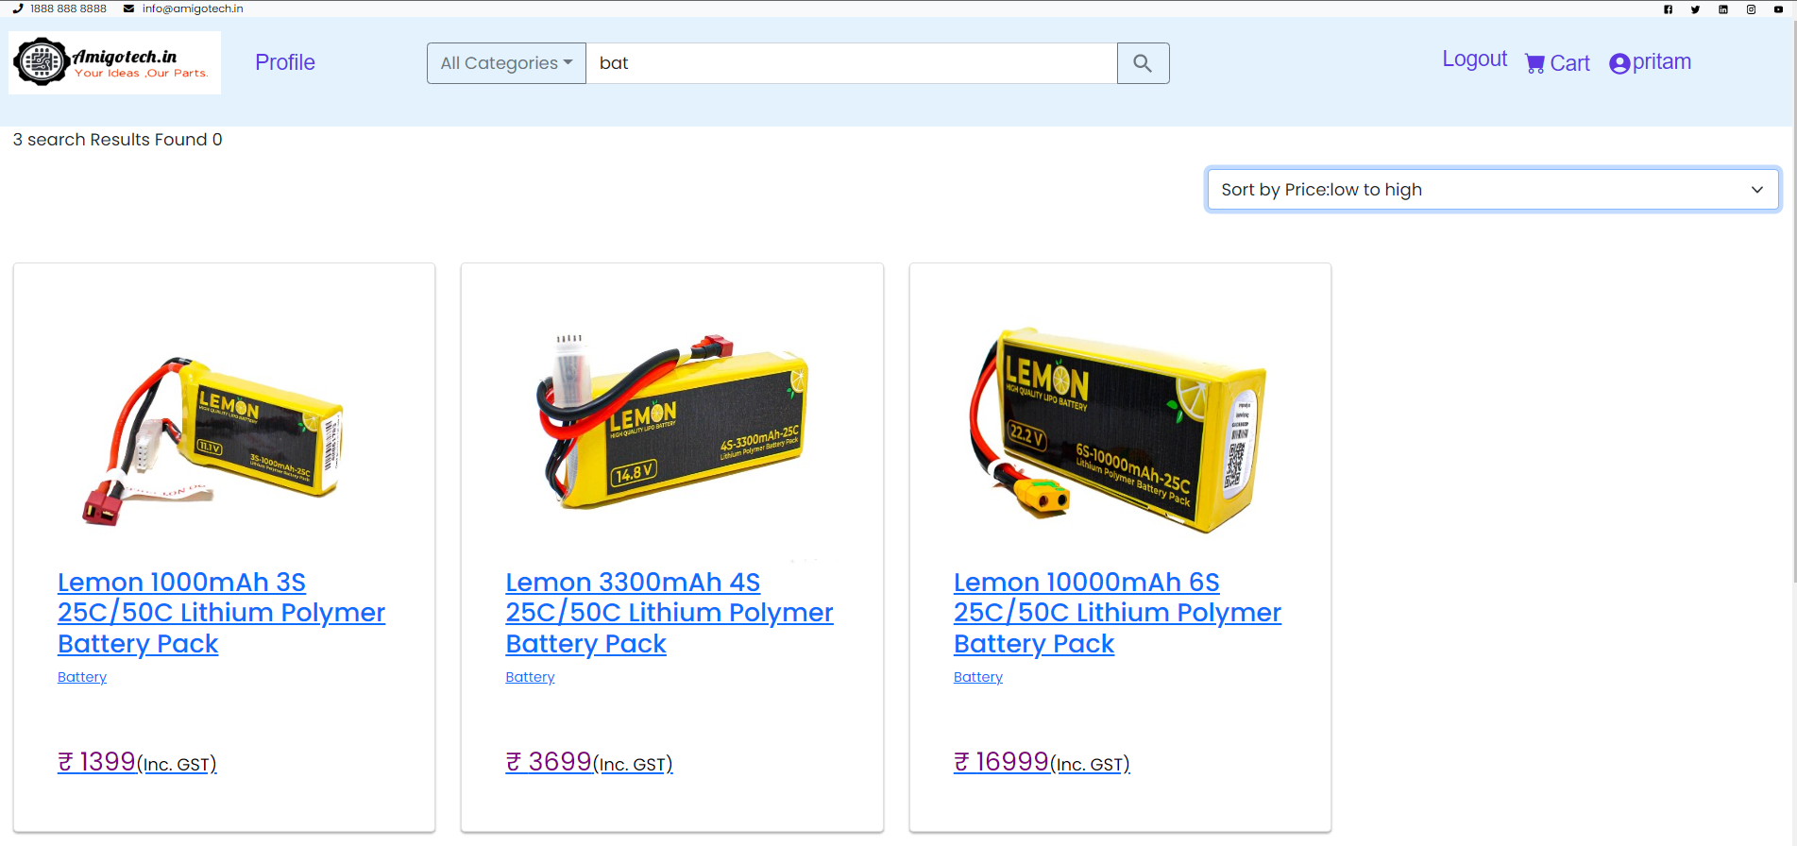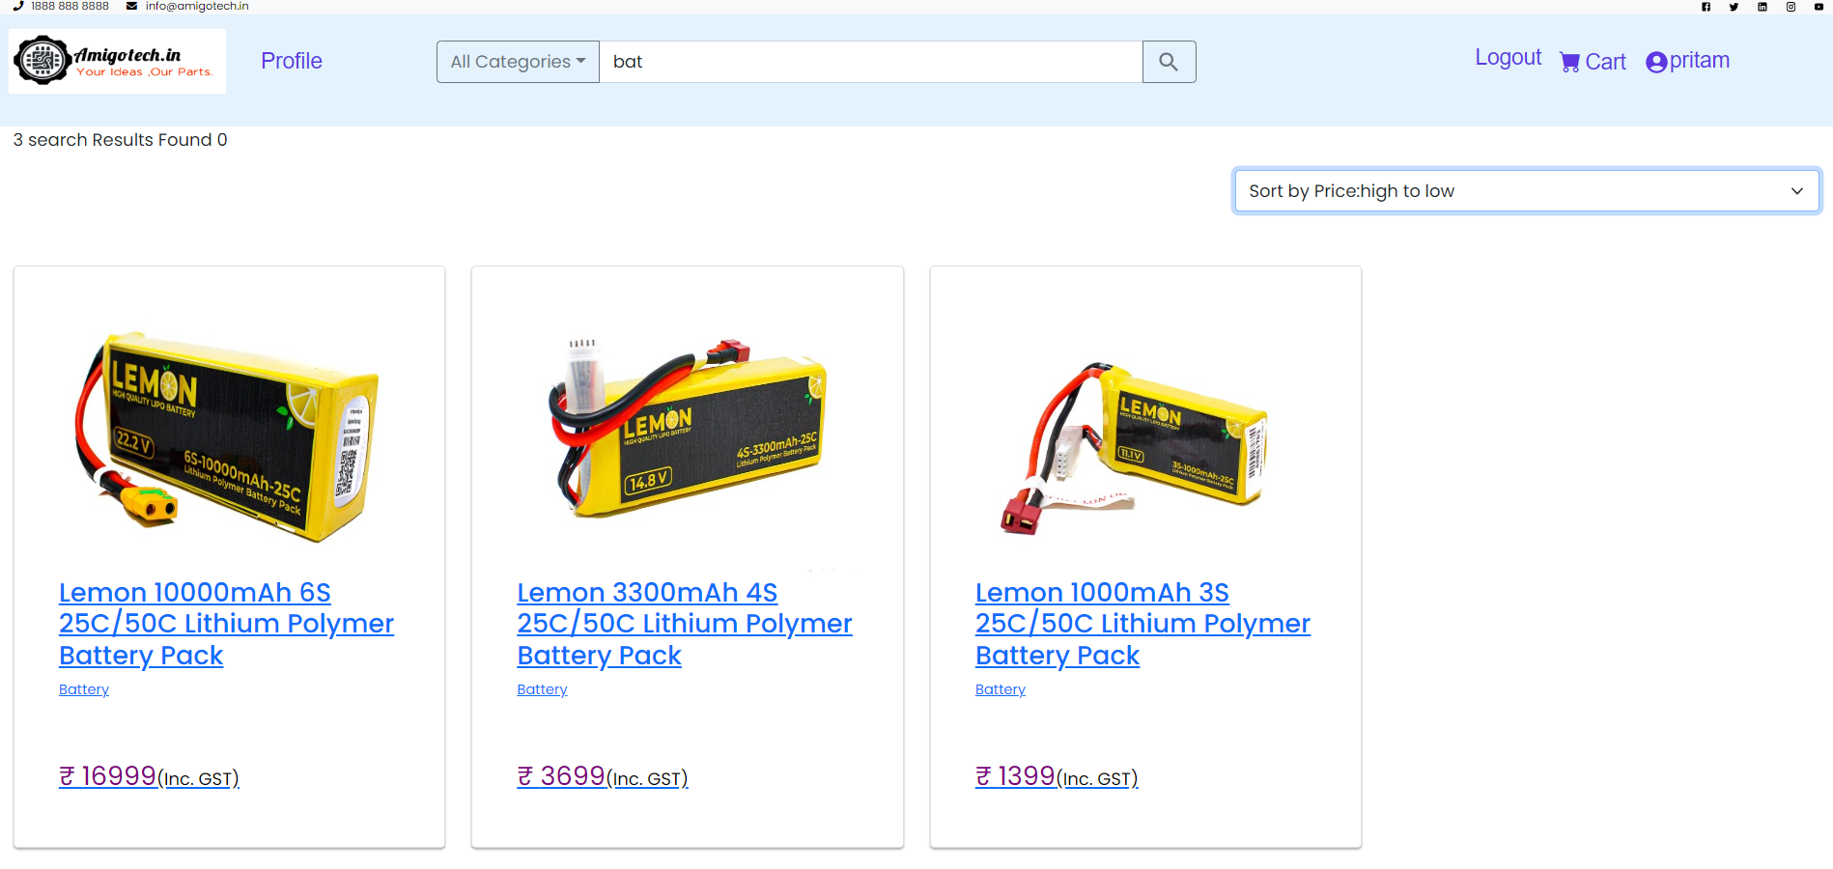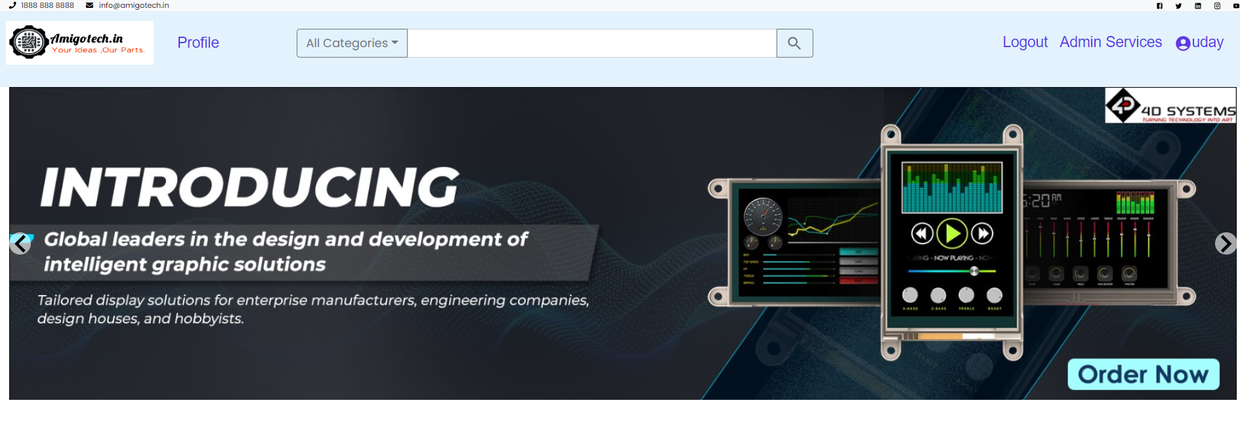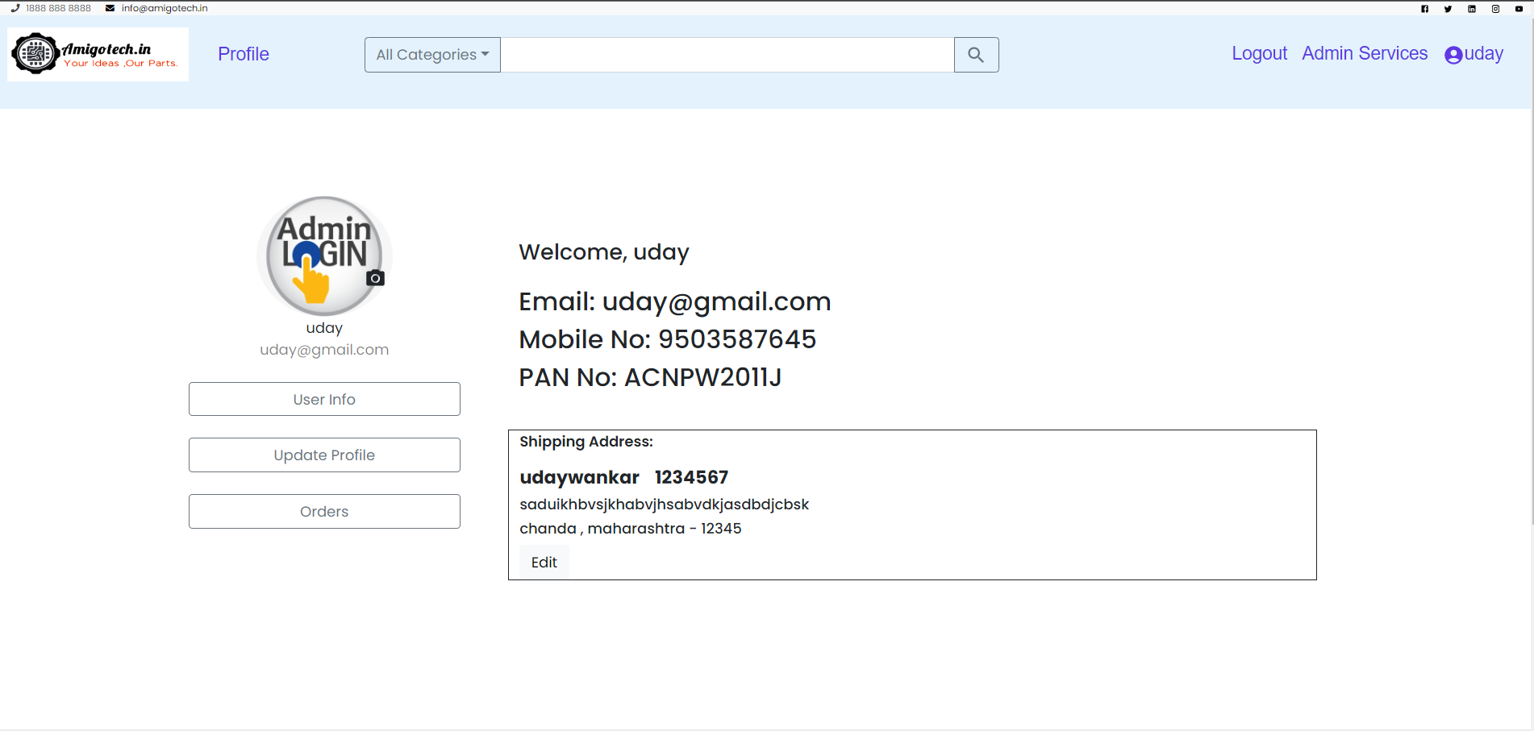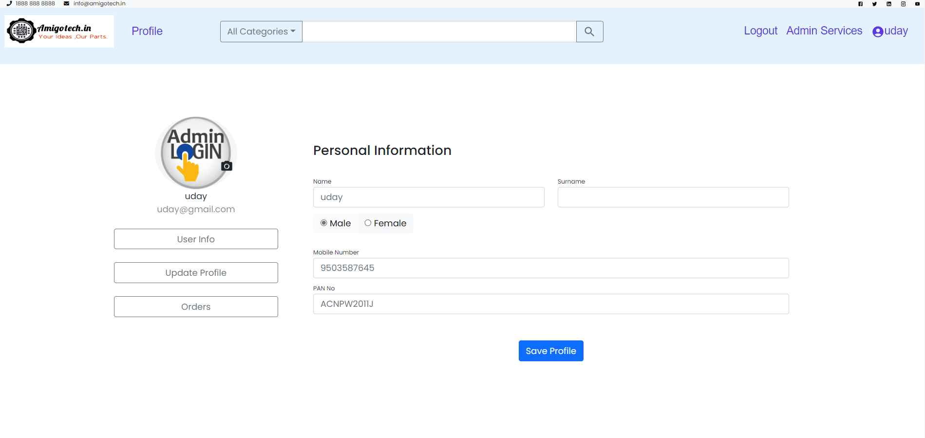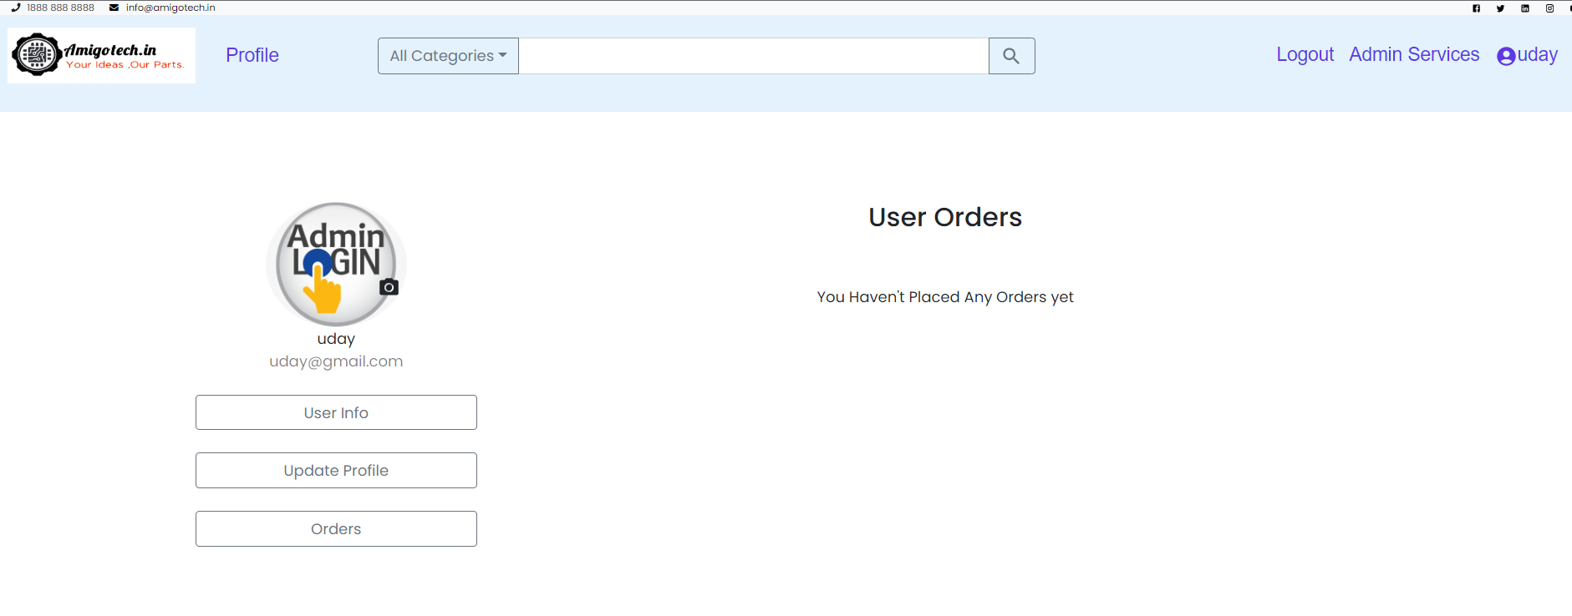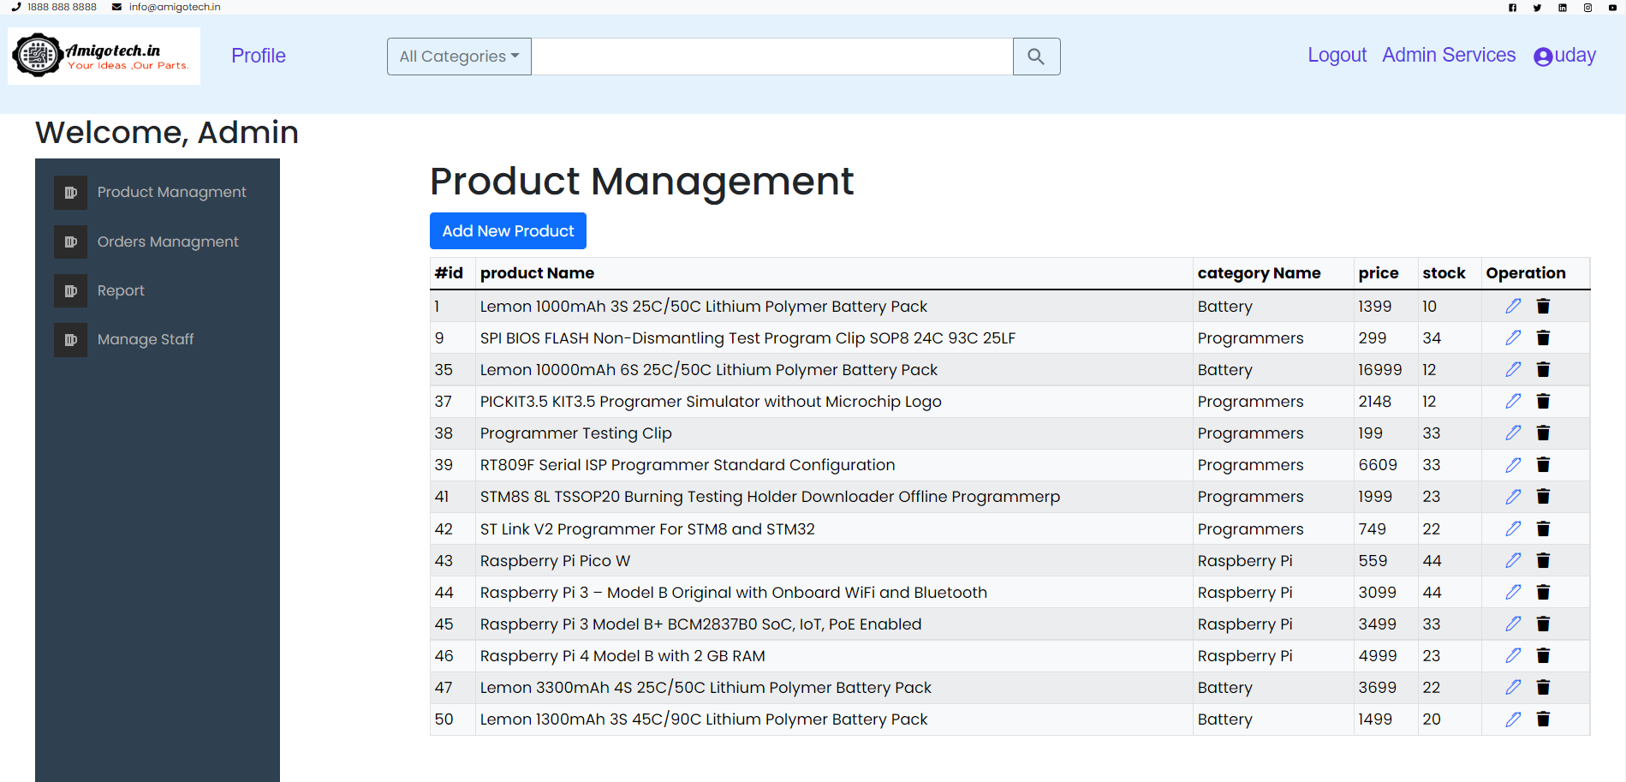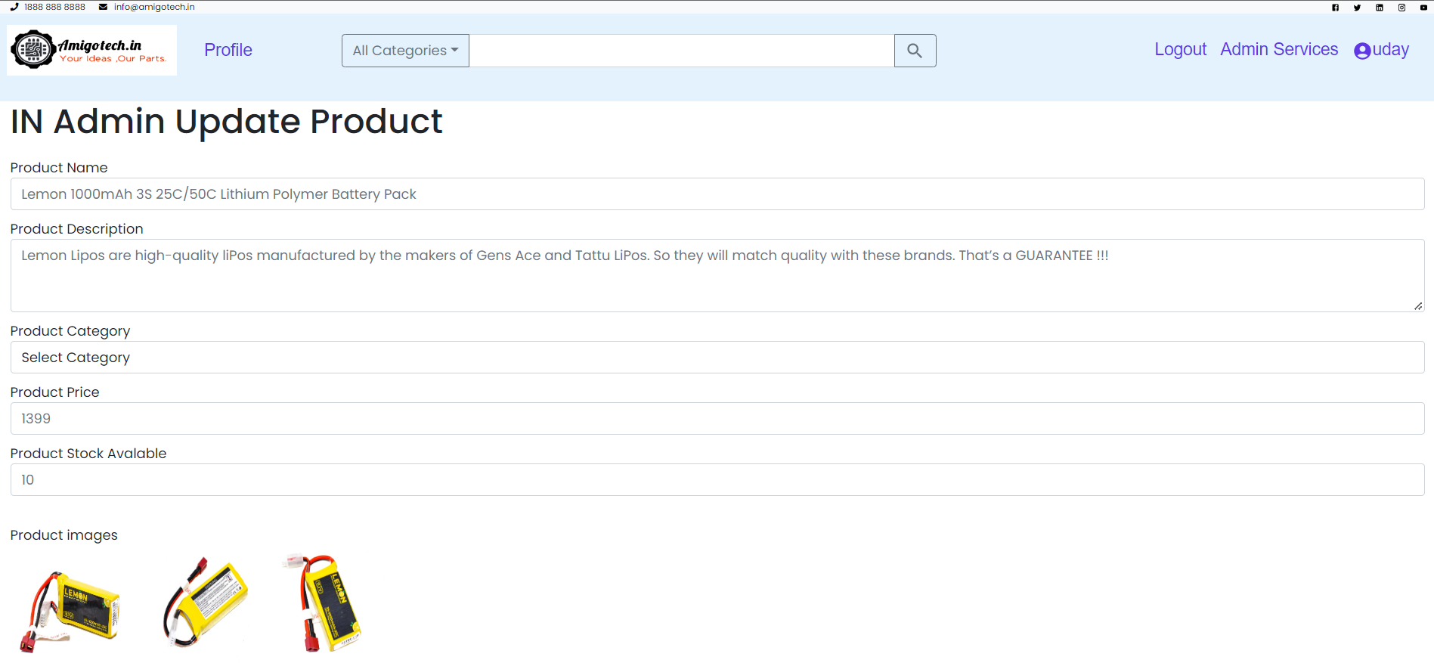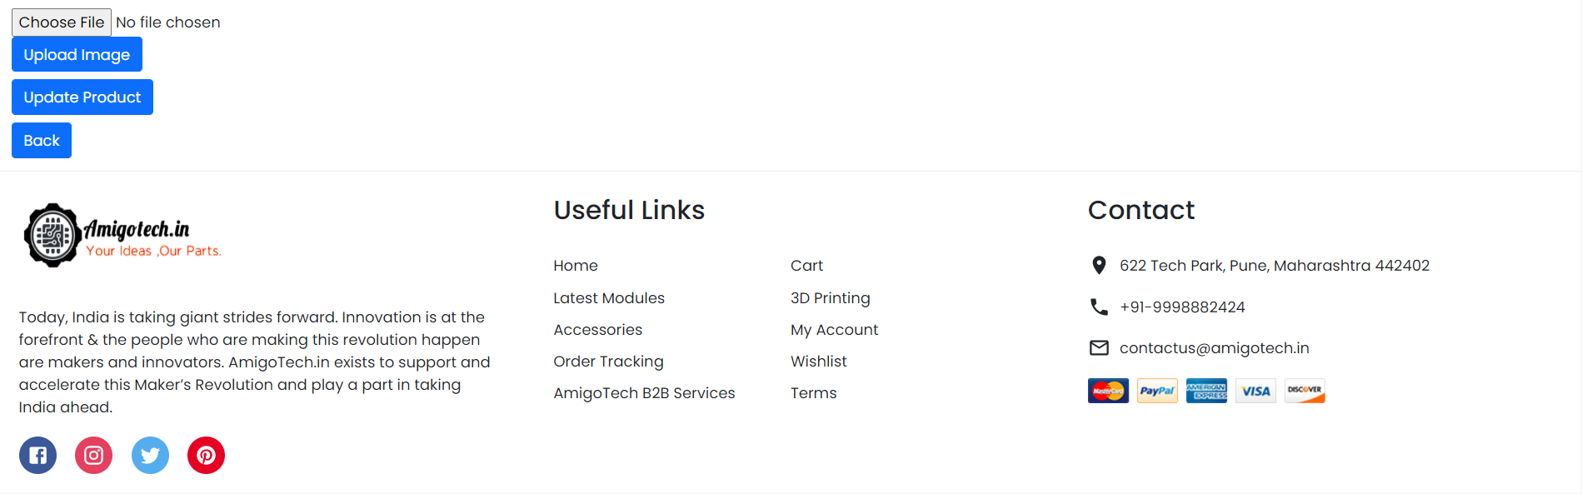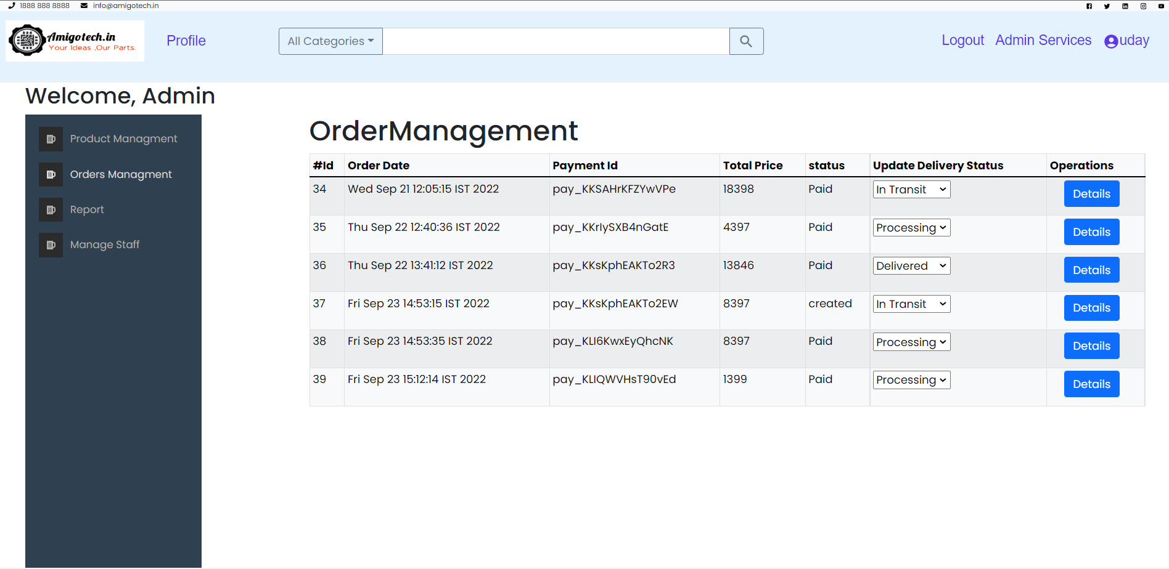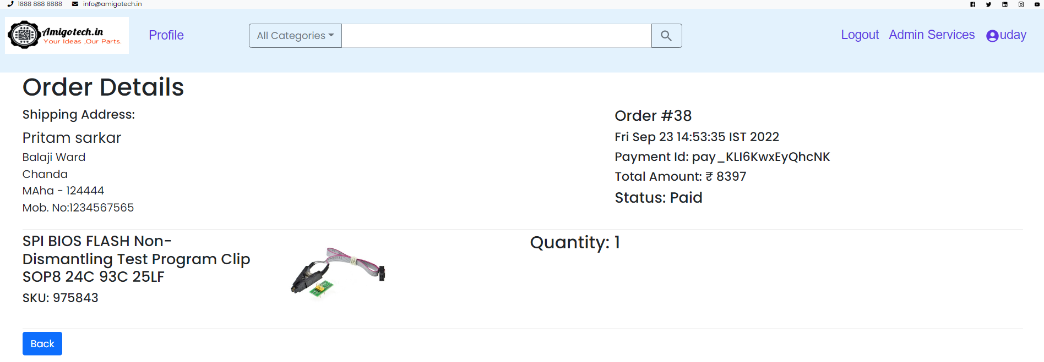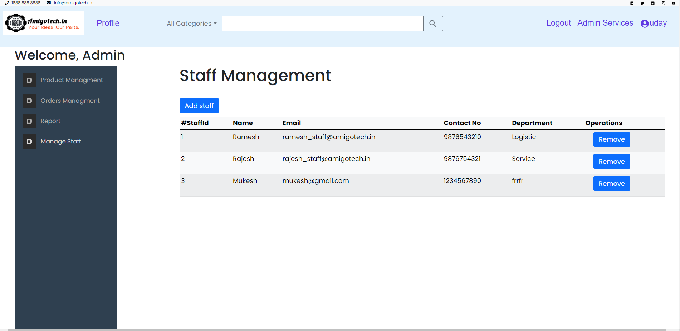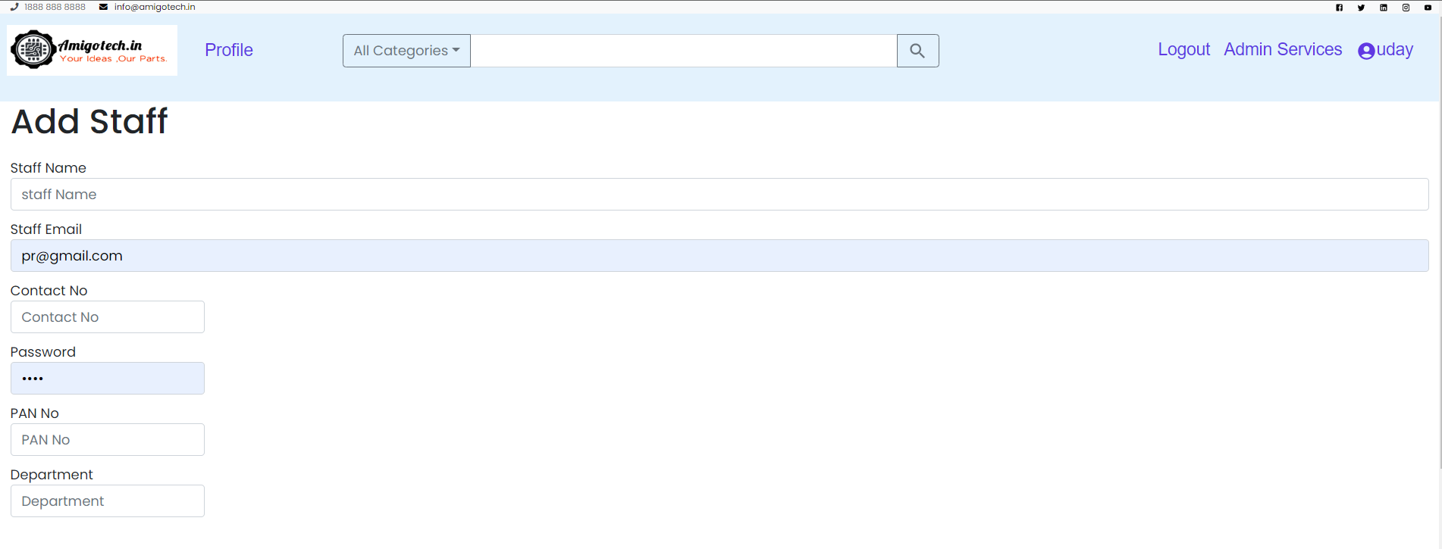

# CONCLUSION

The project entitled **Amigotech.in** is completed successfully.

The system has been developed with much care and free of errors and at the same time it is efficient and less time consuming. The purpose of this project was to develop a web application and an android application for purchasing items from a shop.

This project helped us in gaining valuable information and practical knowledge on several topics like designing web pages using React.js, usage of responsive templates, designing of android applications, and management of database using MySQL. The entire system is secured. Also, the project helped us understanding about the development phases of a project and software development life cycle. We learned how to test different features of a project.

This project has given us great satisfaction in having designed an application which can be implemented to any nearby shops or branded shops selling various kinds of products by simple modifications.

There is a scope for further development in our project to a great extent. A number of features can be added to this system in future like providing moderator more control over products so that each moderator can maintain their own products. Another feature we wished to implement was providing classes for customers so that different offers can be given to each class. System is keeping track of history of purchases of each customer and provide suggestions based on their history. These features could have implemented unless the time did not limit us.

# REFERENCES

## ONLINE REFERENCE

* www.Google.com
* www.w3school.com
* https://react-bootstrap.github.io/layout/grid/
* https://www.npmjs.com/package/react-pro-sidebar
* https://www.devwares.com/blog/create-responsive-sidebar-in-react/
* https://icons.getbootstrap.com/icons/pen/
* https://therichpost.com/reactjs-create-invoice-template-and-export-to-pdf-working-functionality/
* https://lipis.github.io/bootstrap-sweetalert/
* https://www.npmjs.com/package/react-icons
* https://sweetalert2.github.io/#download /